License Manager - User Manual Index

Table of Contents

Introduction 2

Overview 2

Purpose 2

Getting Started 2

Prerequisites 2

User Interface Overview 3

Log In 3

Sign Up: 4

Dashboard 6

Navigation 7

Features 10

License Tracking 10

Compliance Management 12

Administration 14

Managing Licenses: 14

Managing Categories 16

Managing Vendors 19

User Management 21

Managing Project Managers 23

Advanced Features 26

Calendar View 26

CSV Export 28

Customization 29

Minor Changes 29

Major Changes 29

Troubleshooting 31

Common Issues 31

Frequently Asked Questions (FAQ) 33

Appendices 35

Glossary 35

References 35

Contact Information 35

# Introduction

## Overview

License Manager is a comprehensive software solution designed to streamline and automate the process of managing software licenses for organizations. This project aims to simplify license tracking, reduce compliance risks, and optimize software asset management.

## Purpose

The purpose of the License Manager application is to provide organizations with a centralized and automated solution for managing software licenses. By using this application, organizations can ensure compliance with licensing agreements, minimize the risk of non-compliance, and optimize their software asset management. The application aims to streamline license tracking, automate notifications for expiring licenses, and export license CSV, role-based authorization to keep it secure, and statistical representation of license data, all of which contribute to efficient and effective license management.

# Getting Started

## Prerequisites

To install and use the License Manager, please ensure the following prerequisites are met:

* **Operating System**: Windows 10 or later. Redhat 8 or later, CentOS 8 or later.
* **Database**: MySQL version 8.0 or later
* **Runtime Environment**: Node.js version 20.11.1 or later, with npm version 10.2.4 or later
* **Web Server**: One of the following: Nginx, Apache, or IIS

# User Interface Overview

## Log In

When accessing the application, you first see the Login screen. If you have already created an account or create a new account by clicking on the link “Create Your Account”. The application also checks for any previous user session, when accessing the application, if a user session is valid and present you will be redirected to user dashboard directly.

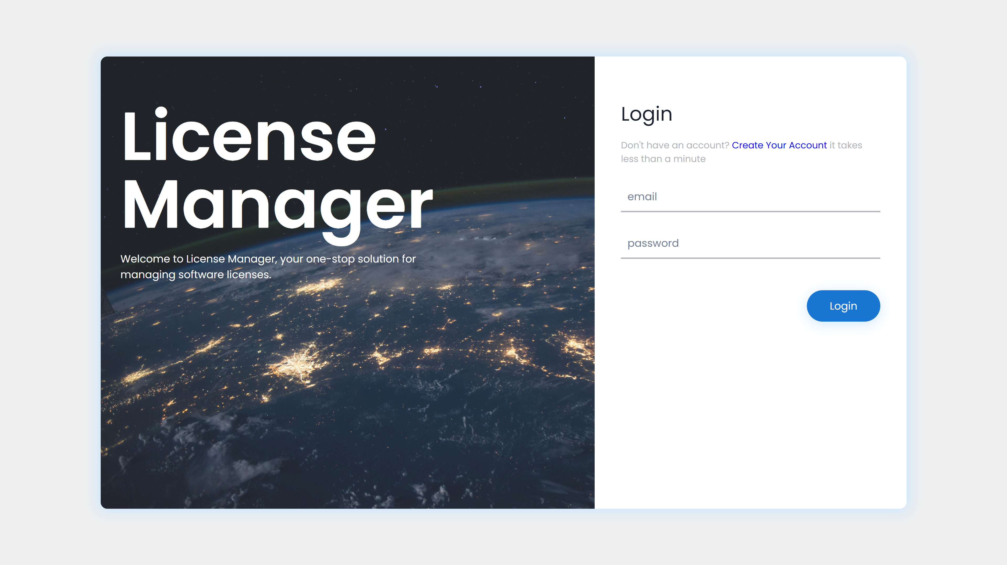

Figure .1: Login page of License Manager

- When logging in, if the credentials are valid and correct, the user will be redirected to the dashboard. If there is an issue, you will see the relevant message as shown below.

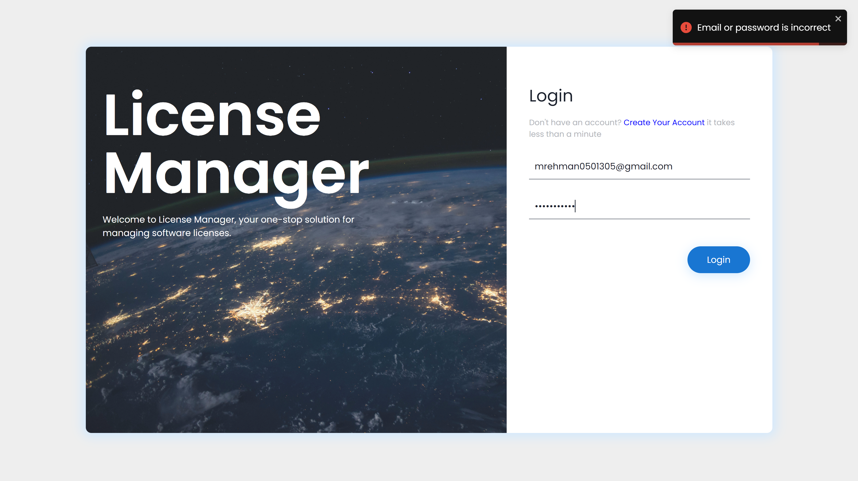

Figure 1.: Example of incorrect credentials

## Sign Up:

The Sign-Up screen requires you to input your username, email, and password. Keeping in mind a user-friendly interface, the design is made self-explanatory.

- The fields have their necessary validations to ensure user security and to make sure the application is robust.

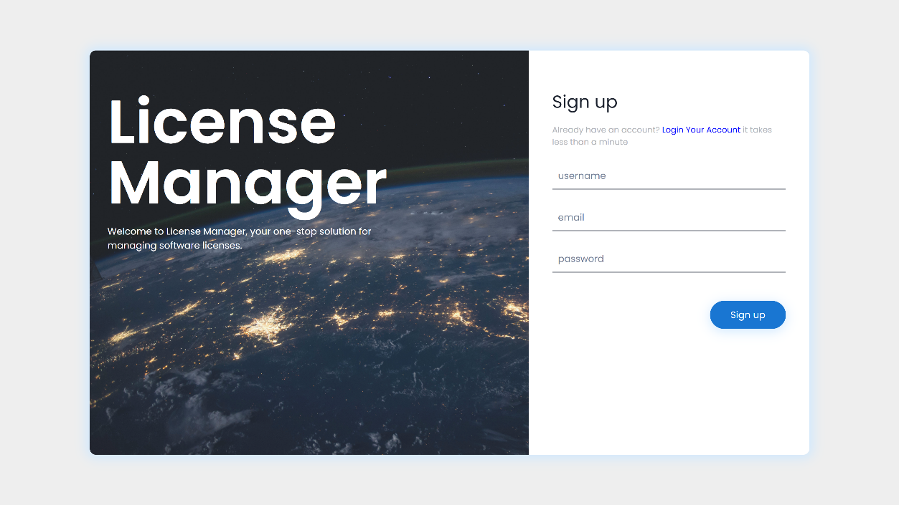

Figure 1.:Sign-Up page of License Manager

- On Successful Registration, you will see a notification regarding it. And in case if there is any error, maybe “server error”, it will also be displayed with the relevant color scheme.

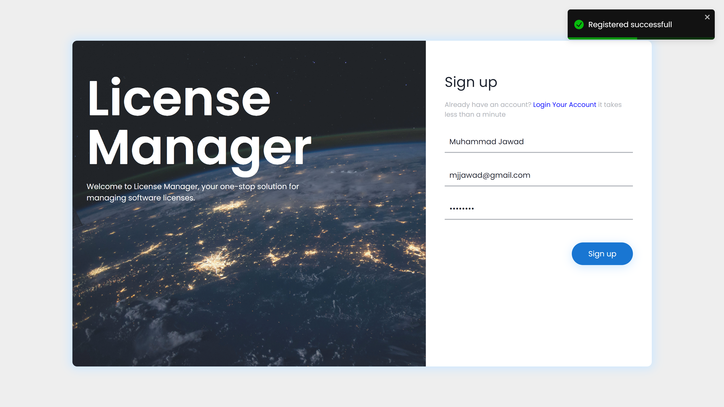

Figure 1.:Example of Successful Sign-Up

Dashboard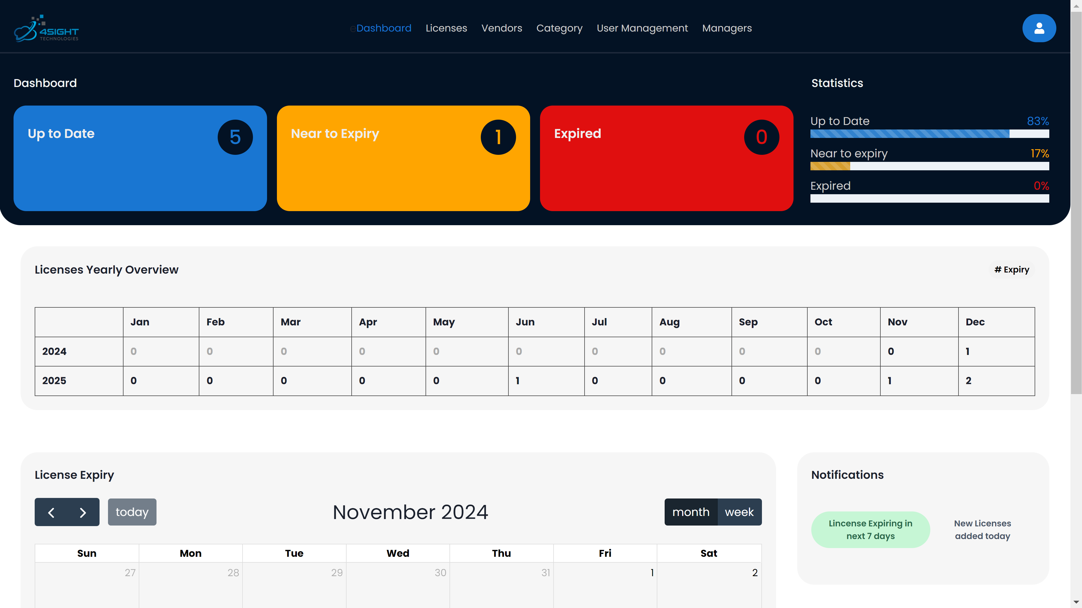

Figure 1.: Overview of dashboard

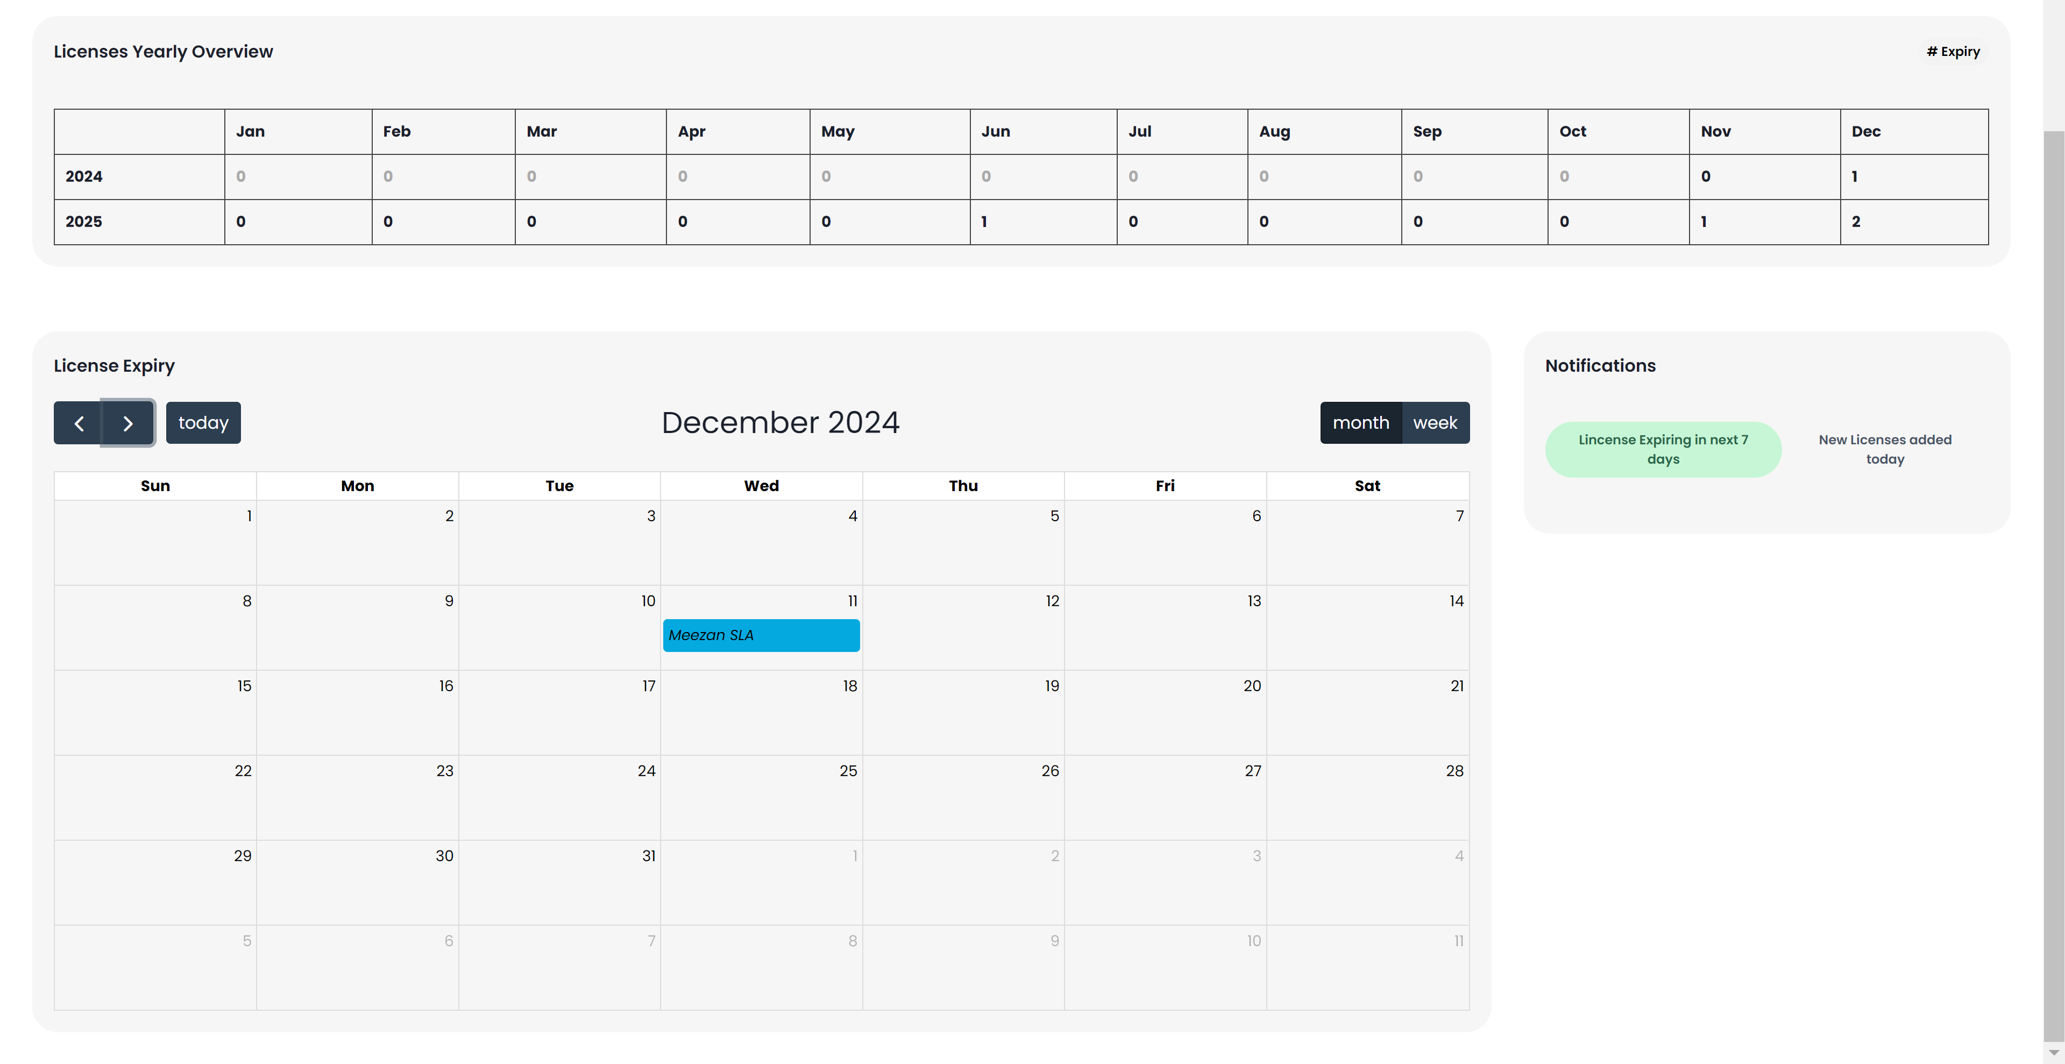

Figure 1.: Overview of dashboard-2

- The dashboard consists of 6 main components:

- First, is the top navigation bar, it navigates to the different tabs or pages of the application

- Second, the three cards displaying the count of licenses according to their status. In the example, we can see that I have 5 licenses with status “Up to Date”, 1 license with status “Near to Expiry” and no license with status “Expired”.

- Third, the statistics component, it shows percentage view of the same information, displaying the contrast between licenses status in percentage.

- Fourth, the Licenses Yearly Overview, whilst being a small component, it shows a clear overview regarding license expiry of the current year and the subsequent year. As in the example, in 2025, I have 1 license expiring in June, 1 in November and 2 in December. This component makes it easy to understand which month is most saturated in terms of license expiry

- Fifth, the License Expiry, this component is a more in-depth view of the previous component. It shows the license expiring on their exact date. We can navigate to upcoming months and if we see a license and want more info on it. The user can simply click on it and he will be redirected to the licenses tab and the necessary filter will be applied to only showcase the selected license.

- Lastly, the notifications component, it consists of two tabs, one tab shows the licenses expiring in next 7 days, the application does send reminder emails in 30 days of threshold. And if still a license has reached the 7 days limit, to bring attention to it, it will be displayed here. The second tab shows the user the licenses that have been added in the day.

## Navigation

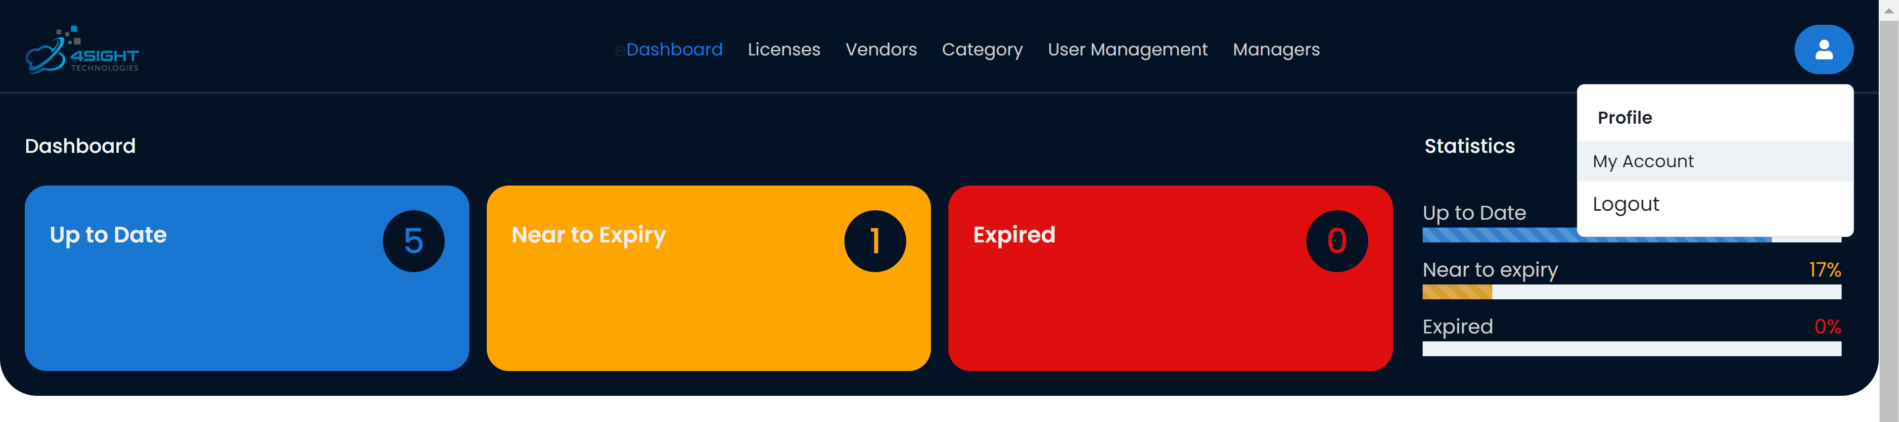

Figure 1.: Highlighting the top navigation bar

* The top bar is visible on all tabs and gives an easy and direct to access to any page the user wants view. The current page that is viewed is highlighted by blue text which helps the user know his location. Additionally, as a user can have three roles, normal user, admin and super admin, these options change based on the user role assigned. However, super admin will only be a single user, and he will be the user that signs up initially.

Licenses tab

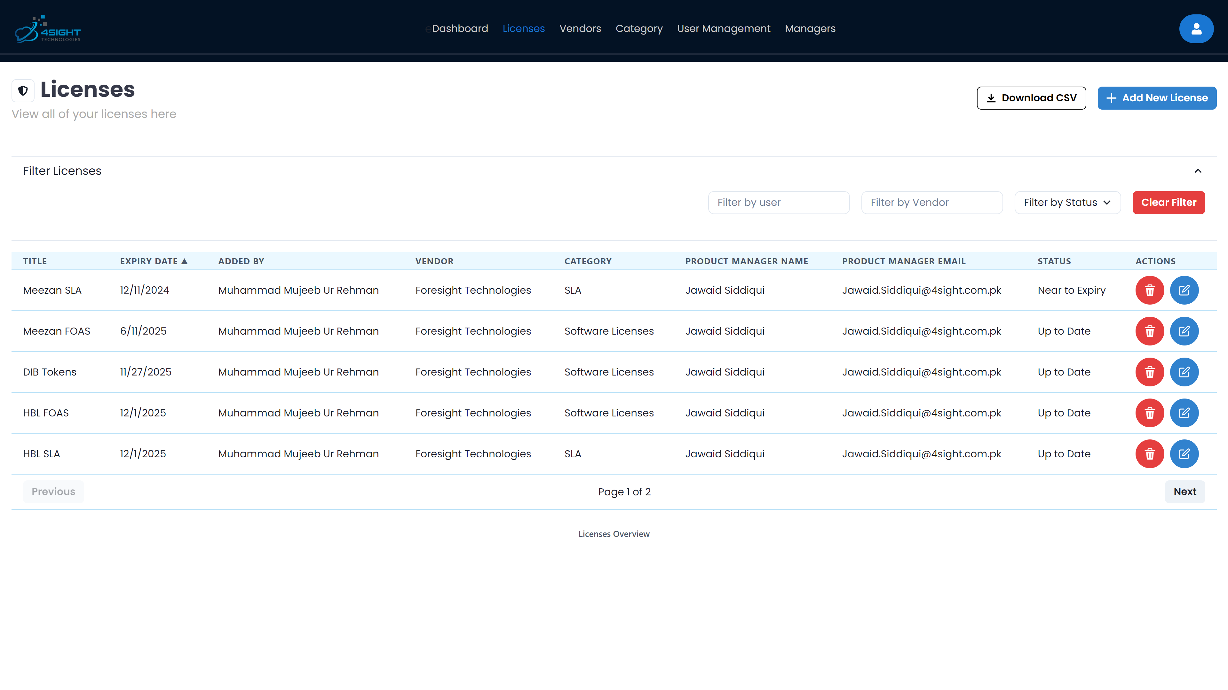

Figure 1.: Overview of Licenses page

Vendors tab

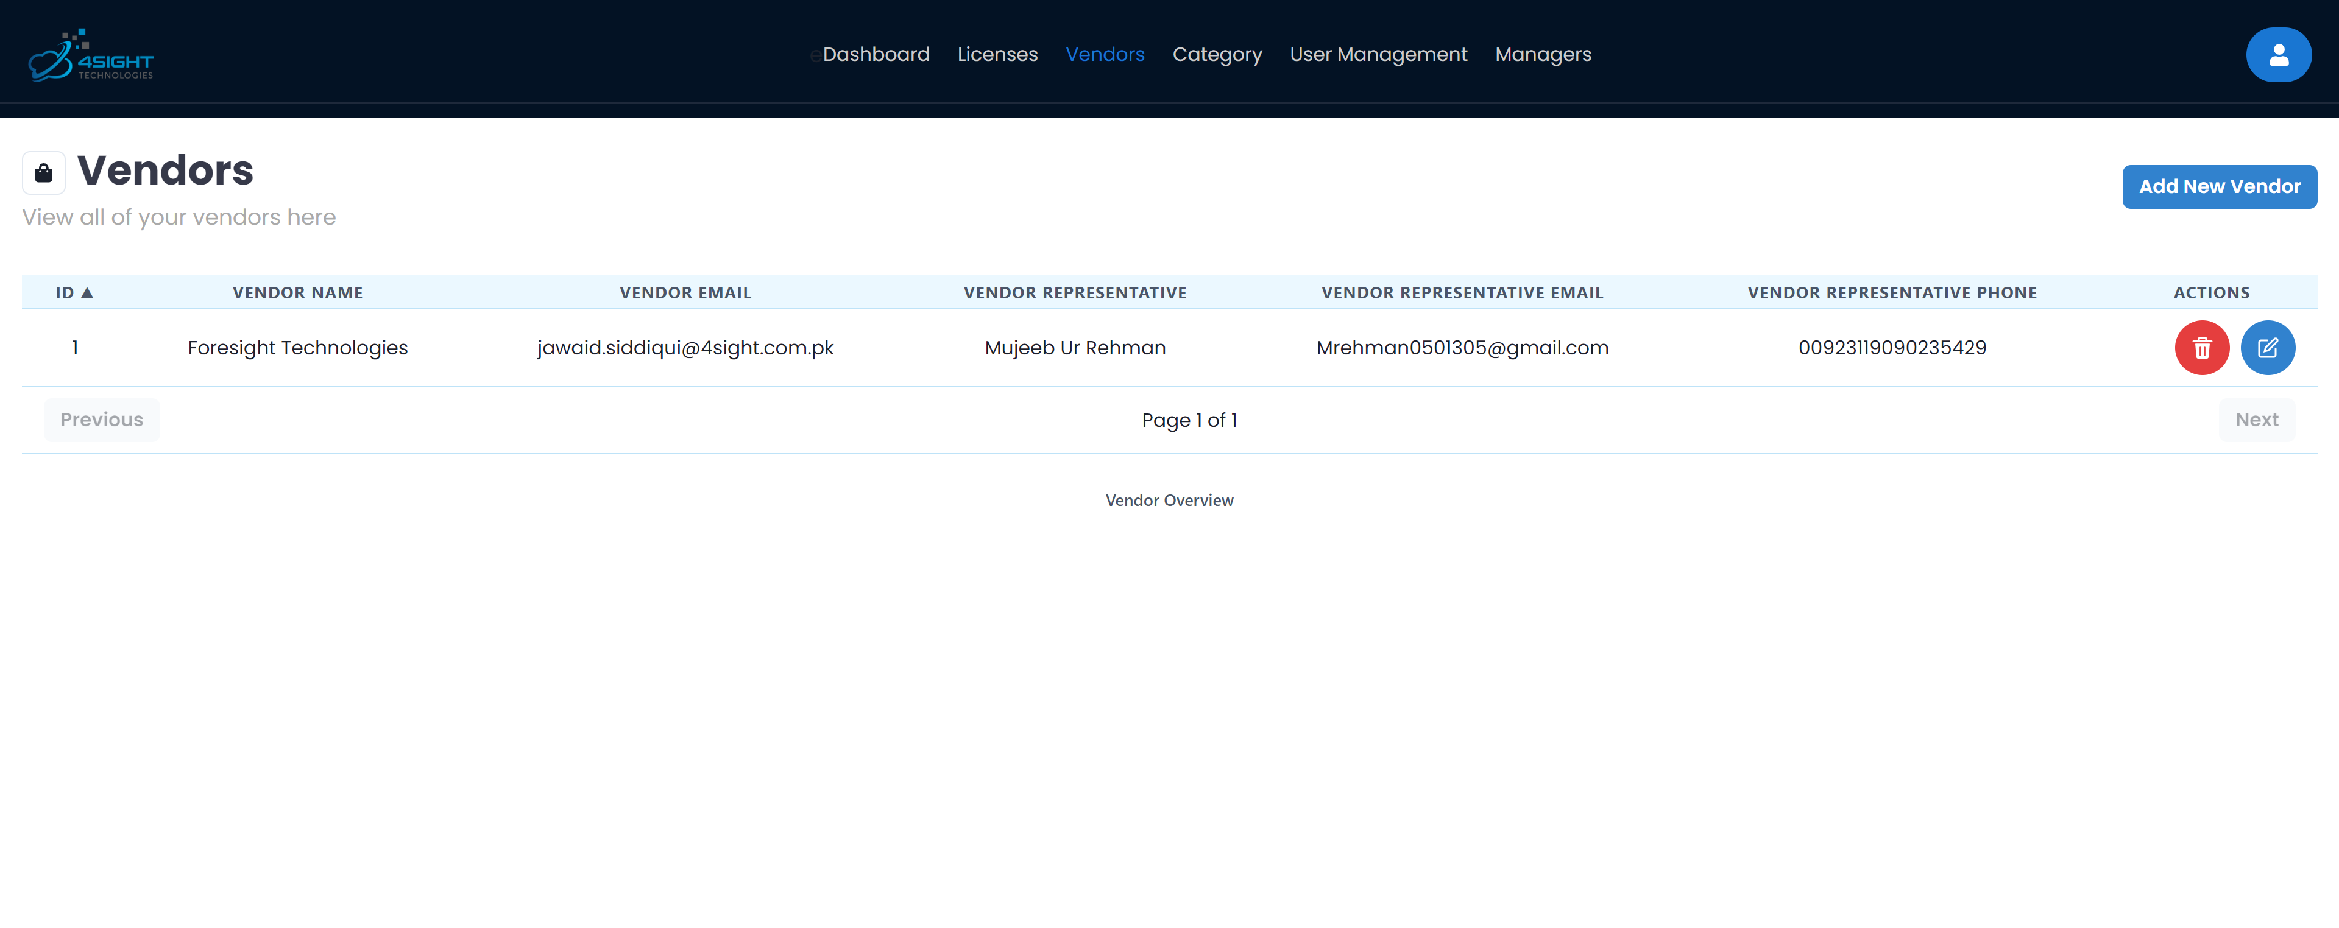

Figure 1.: Overview of Vendors page

Category tab

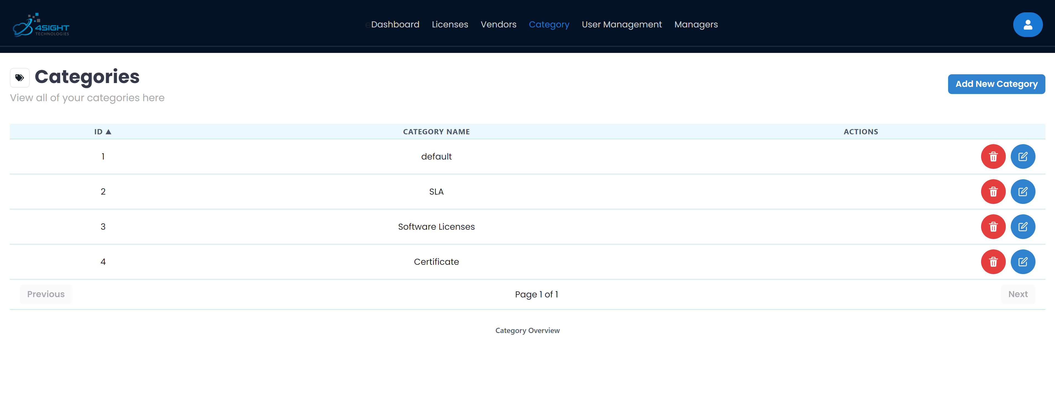

Figure 1.: Overview of categories page

User management tab

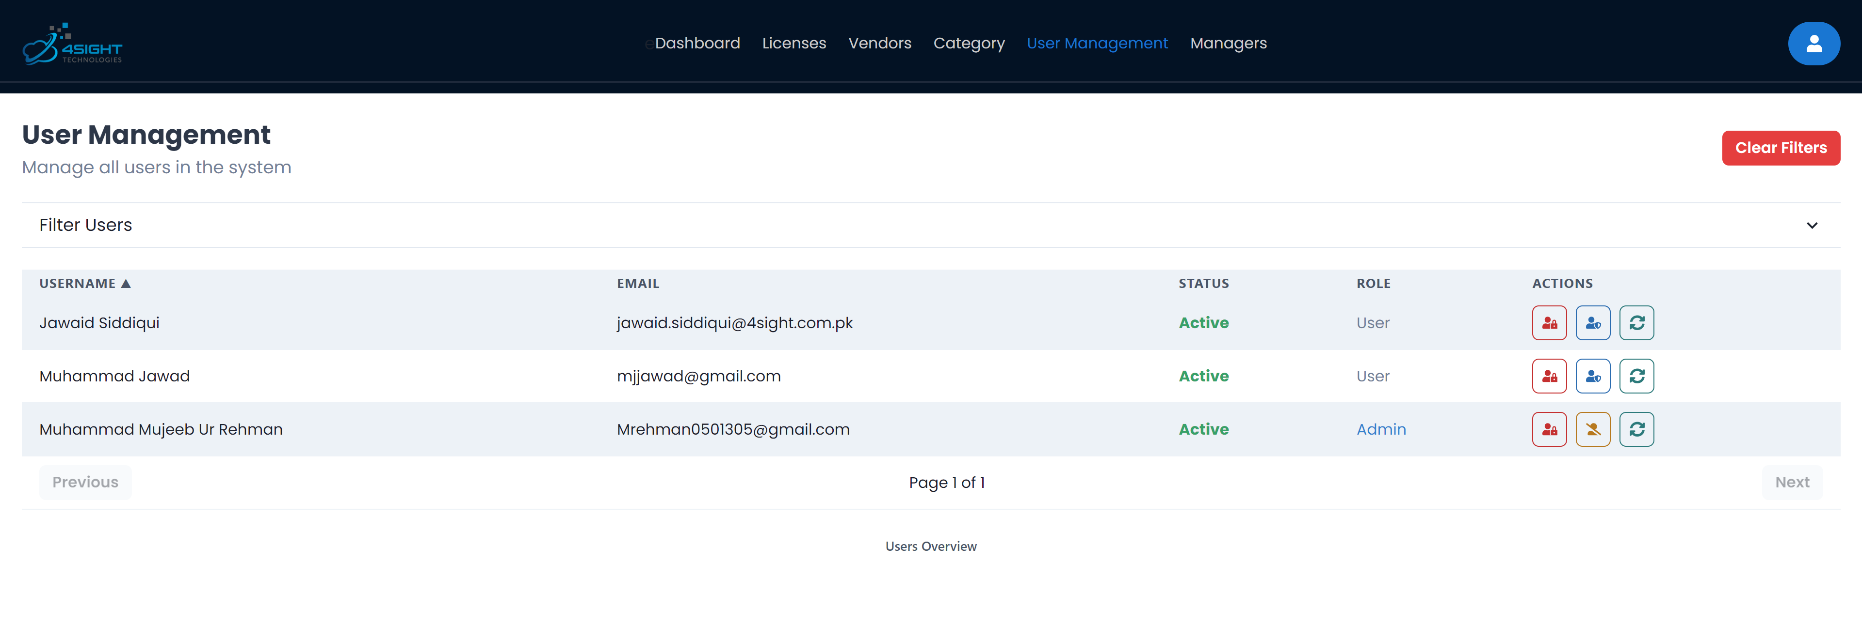

Figure 1.: Overview of User management page

Managers tab

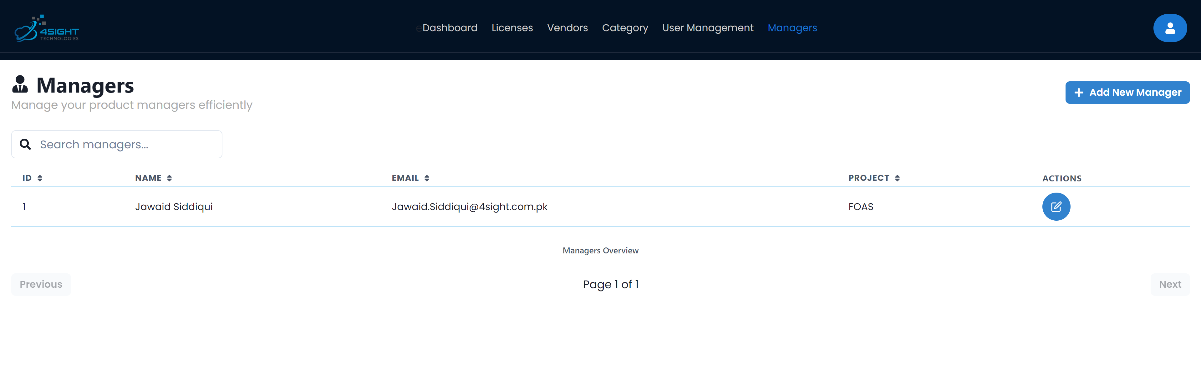

Figure 1.: Overview of Managers tab

My Profile

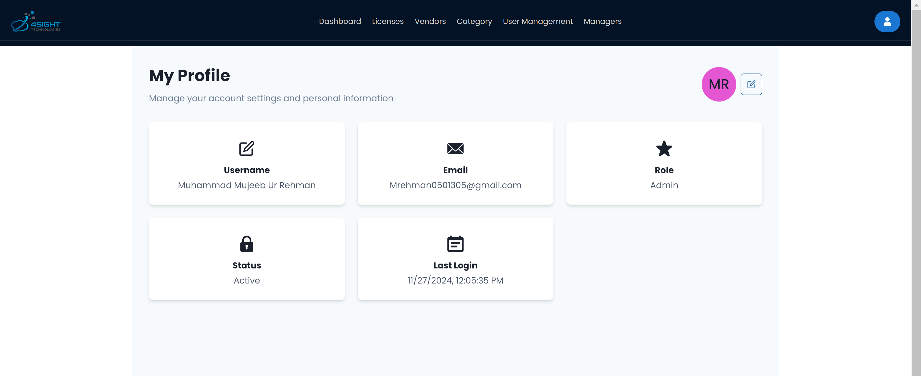

Figure 1.: Overview of my profile page

# Features

## License Tracking

- Viewing Licenses: All licenses are listed with the necessary information in a tabular format. Moreover, to keep a clean interface and easy to navigate pagination has also been implemented.



Figure 2.1: Licenses page options

- Sorting Licenses: the table gives you the ability to sort the licenses using any column by simply clicking on the column name in the table. The “up” arrow denotes ascending order and the “down” arrow denoted descending order.

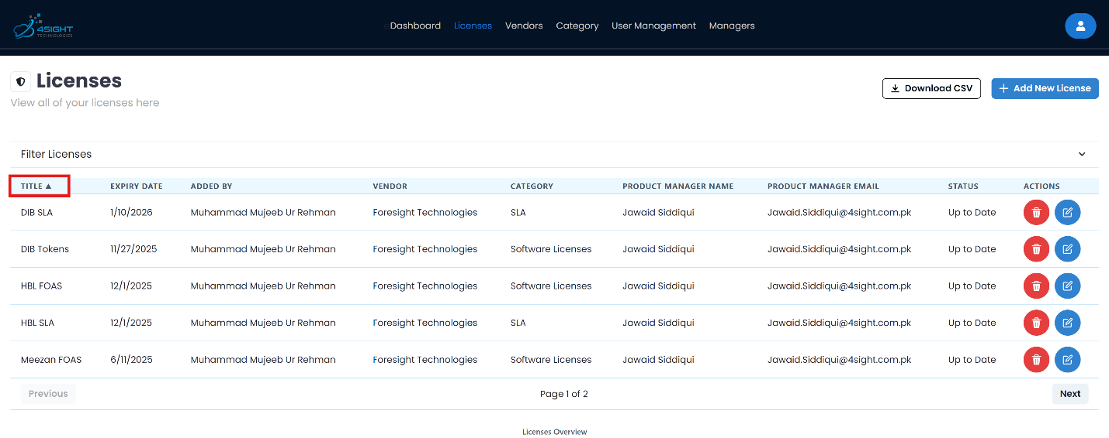

Figure 2.2: How to sort licenses

- Filtering Licenses: we understand that a user might have significant count of licenses, hence the user can filter the licenses by user, vendor and status. To clear filter, a button is added to make it a single step.

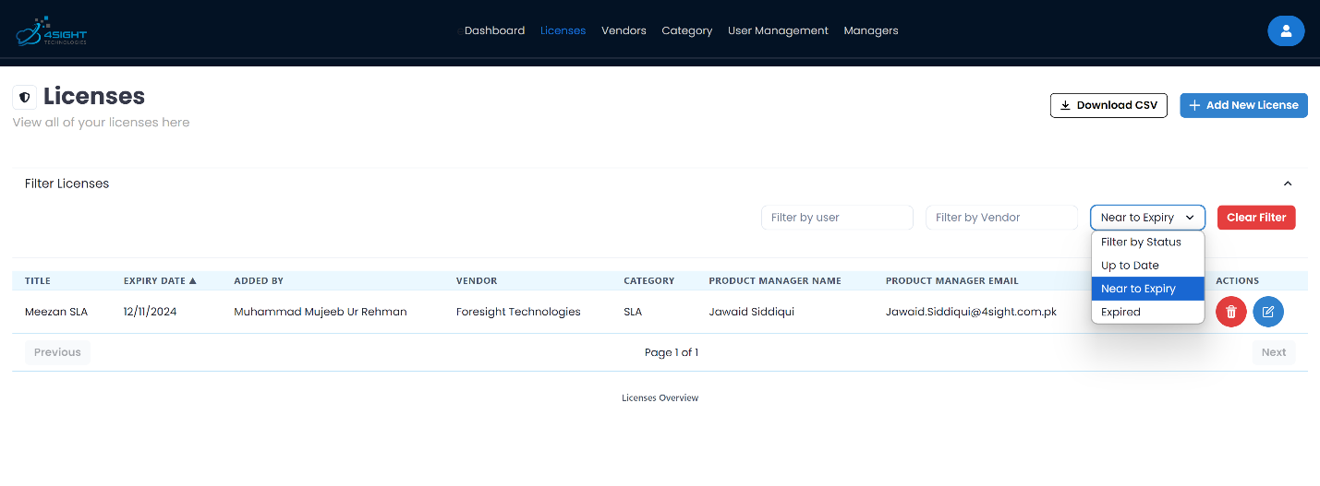

Figure 2.3: How to filter licenses

## Compliance Management

Automated Notifications: the application notifies about “Near to Expiry” licenses through email, and subsequently on the dashboard. The threshold for email notifications is set to 30 days and for the dashboard it is set to 7 days proximity. The email notification has a fixed time of the day where it checks all the licenses status and if it finds a license that is near to expiry it sends a reminder email to the product manager and the user who had added the license. This reminder is sent everyday once to make sure all deadlines are timely catered.

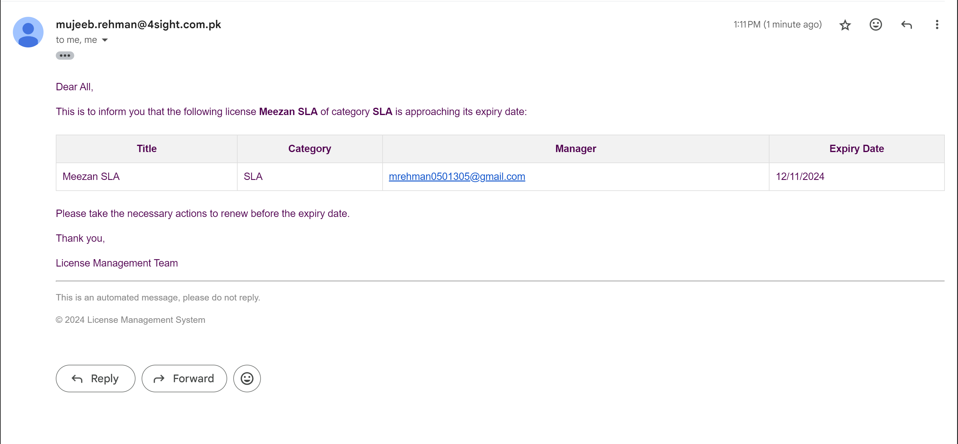

Figure 2.4: Example of automated license notification through email

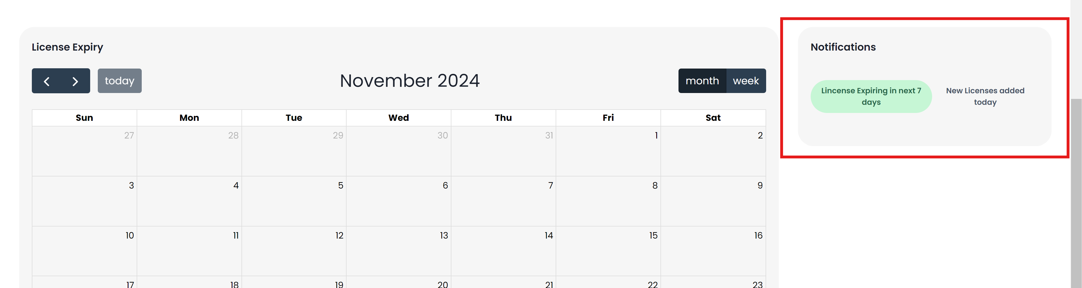

Figure 2.5: Highlighting license expiry info on dashboard

License Analytics: to effectively communicate the analytics of licenses, the information is directly shown on the dashboard. By reviewing these three components, the user is well informed regarding their standing of licenses. Introduction of these three components can be found in the dashboard section of the manual.

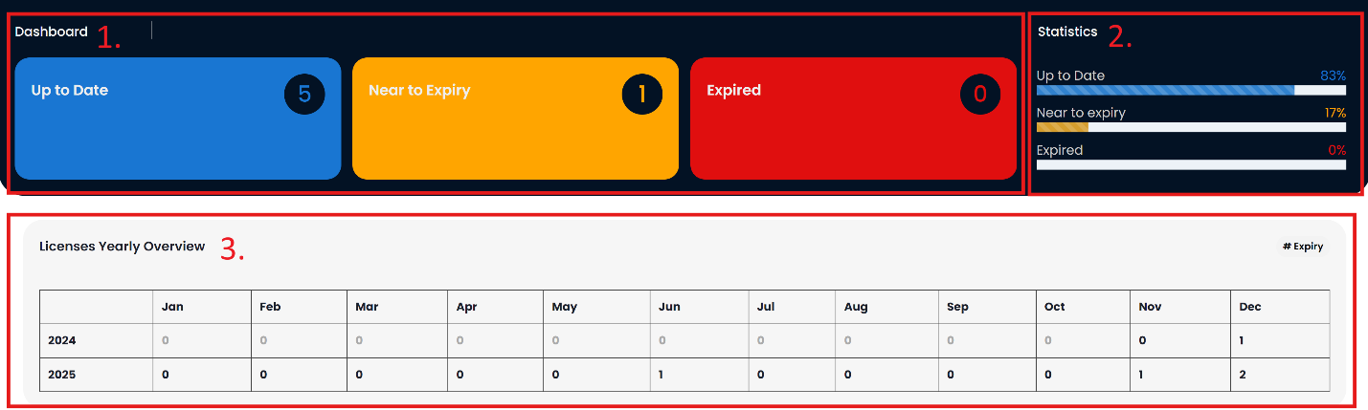

Figure 2.6: View of components displaying license analytics

License Manager logs: In order to not overly populate the database with logs, the application only focuses on the license logs, which means when a license is created, updated, or deleted, a log is created in the database that mentions the action and the user.

# Administration

## Managing Licenses:

All management of licenses are done using the licenses tab found in the top navigation bar.

Creating Licenses

To add a license there are two easy steps. First, click on the “Add New License” button. You will be prompted with a modal to input details of the license. Once you are done filling in the form, simply click “Save” and the license will be added and the record will be updated real time.

Note: Before adding a license, it is required that you add a product manager and a vendor to assign the license. To learn how to add the following please follow the steps for it listed below.

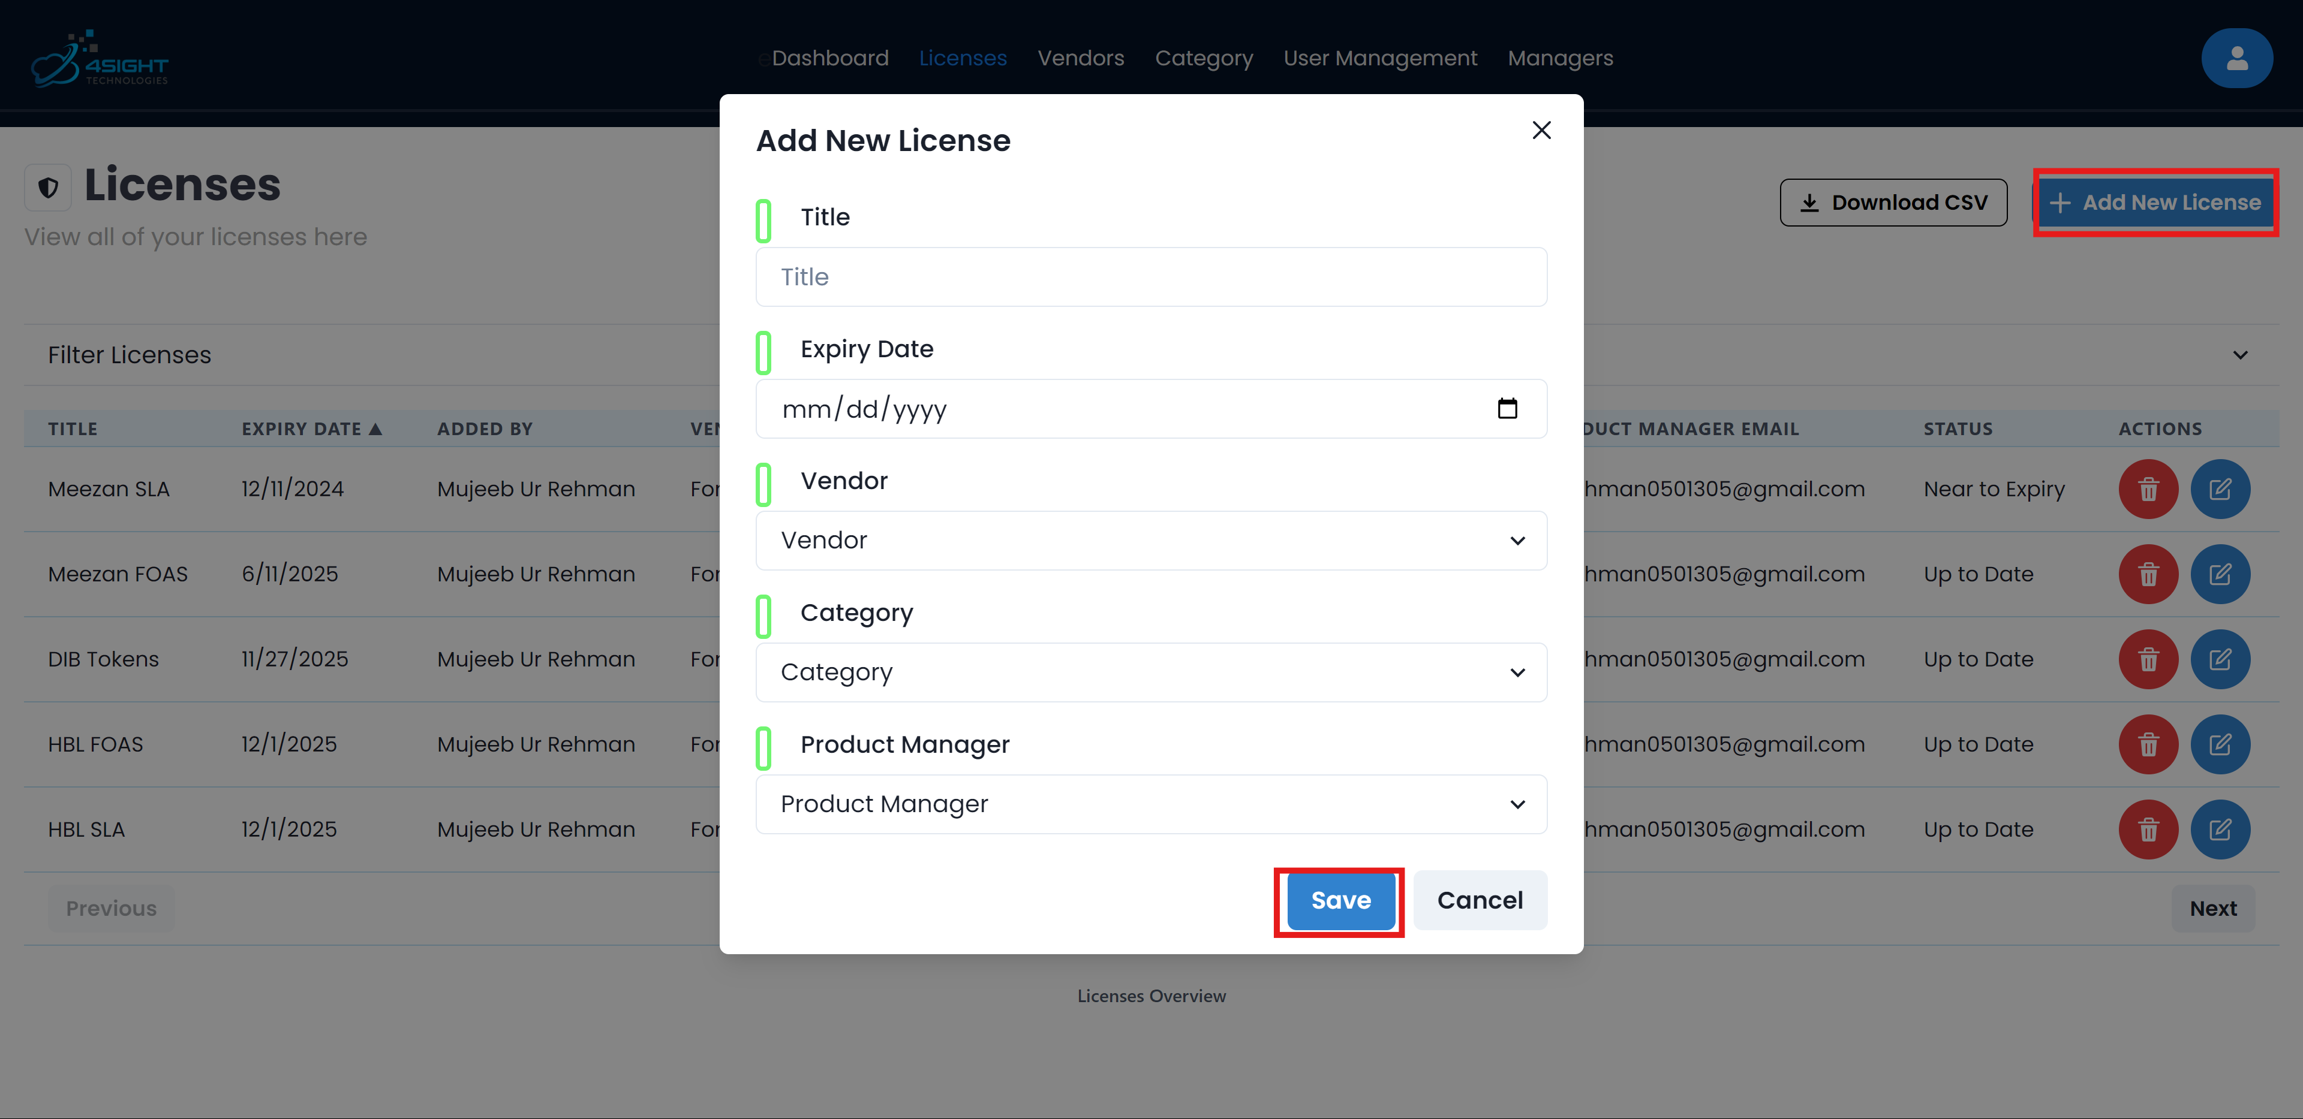

Figure 3.1: Example of how to add a license

Editing Licenses

In order to edit a license simply click on the individual license “Edit” icon. Clicking it will trigger a drawer that would let you edit the license information. After editing the information, click on the “Submit” button and the effects will be seen instantly.

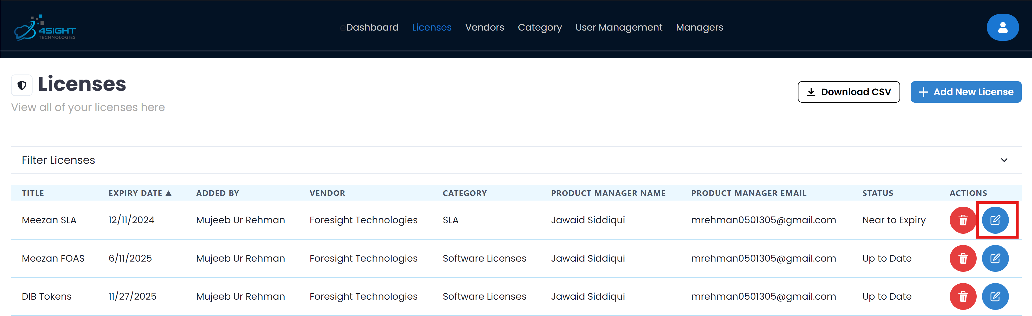

Figure 3.2: Step-1 to edit a license

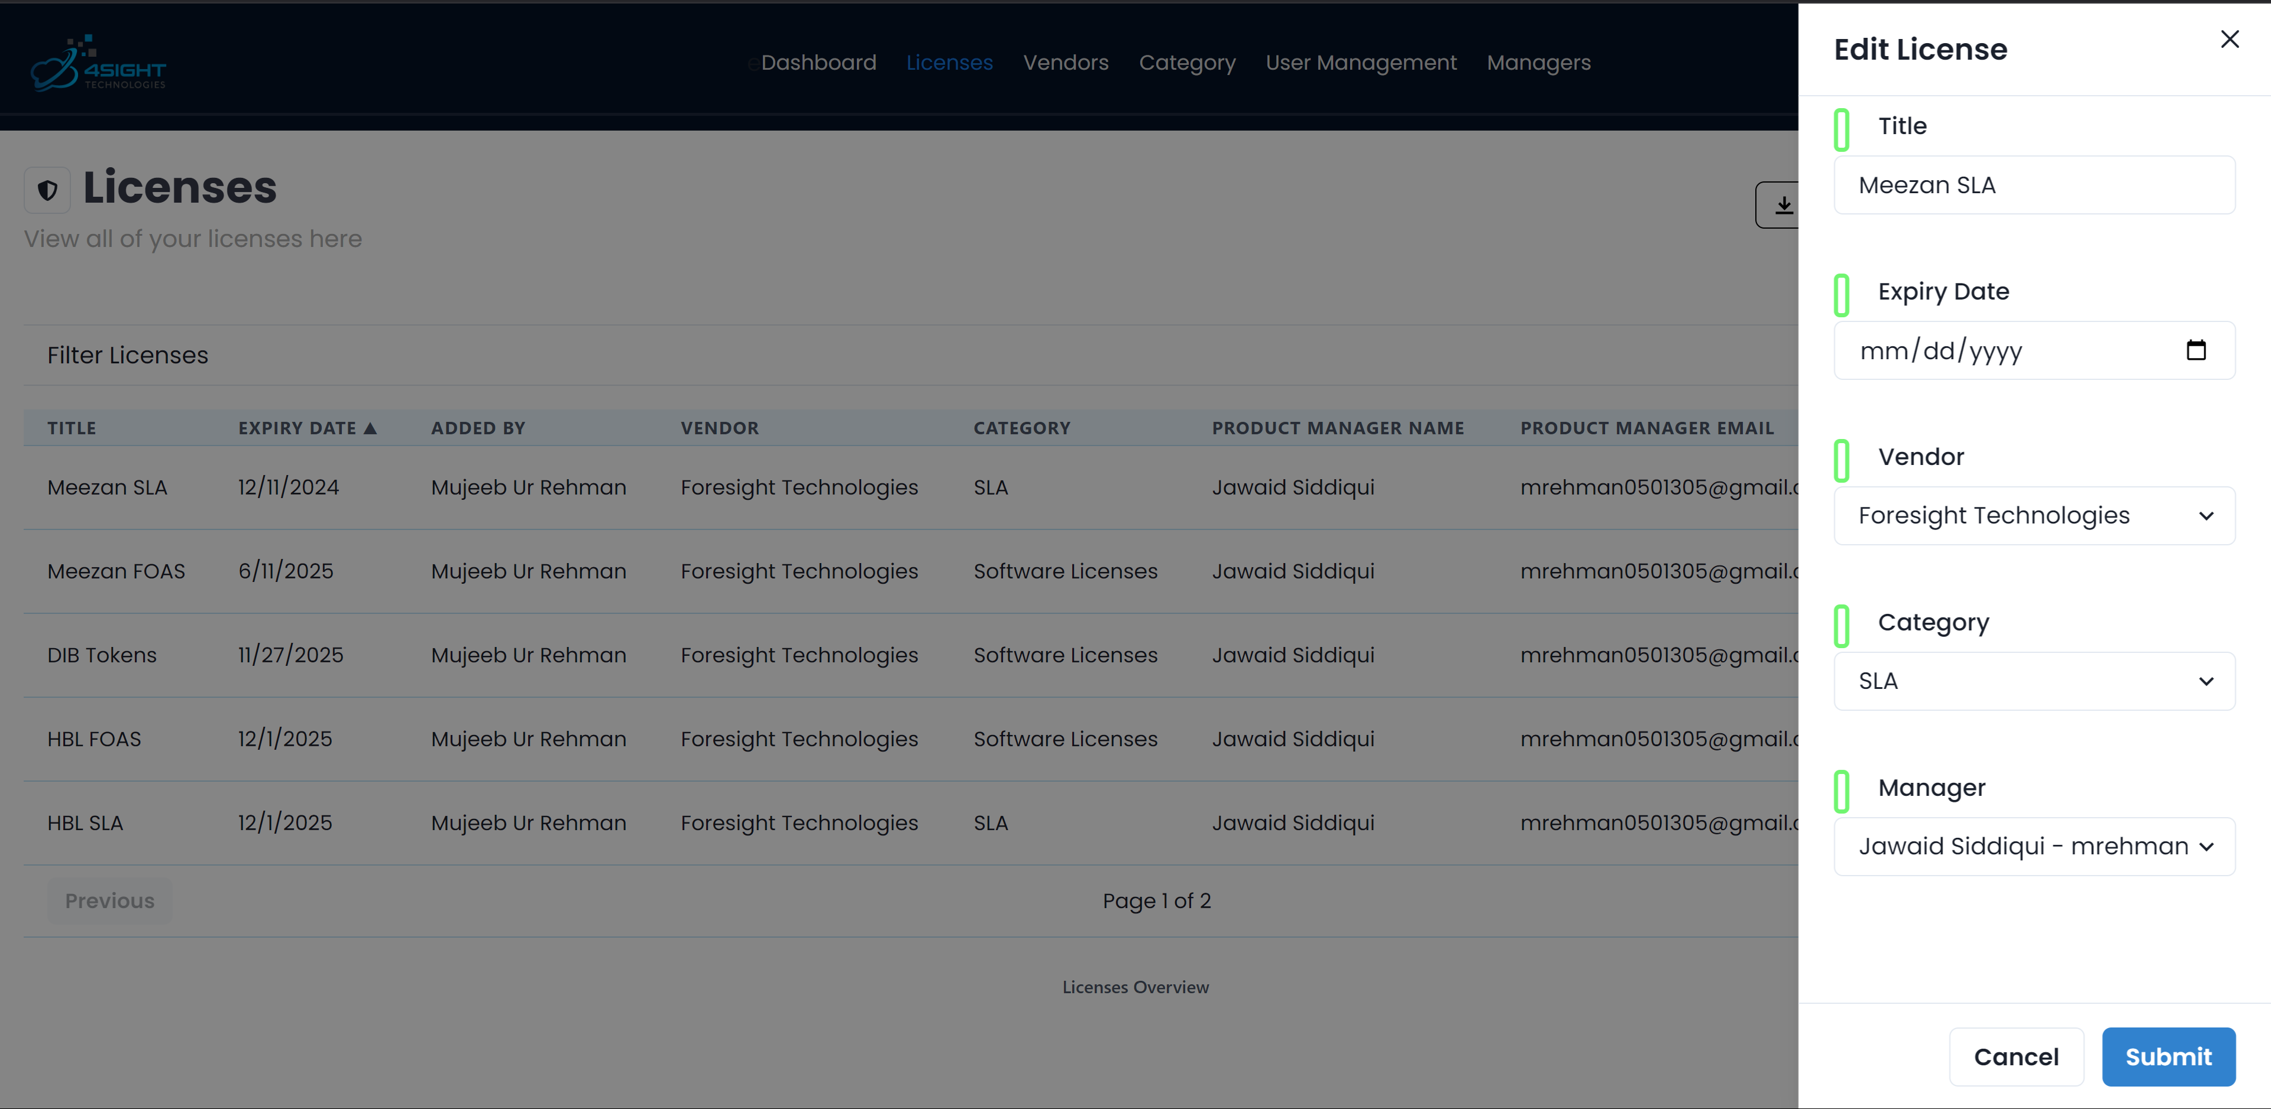

Figure 3.3: Step-2 to edit a license

Deleting Licenses

Coming to deleting a license, it involves two simple steps. First, click on the delete icon appearing beside a license. Finally, click on “Delete” to successfully delete the license. It is worth noting that only Power Admins can delete a license.

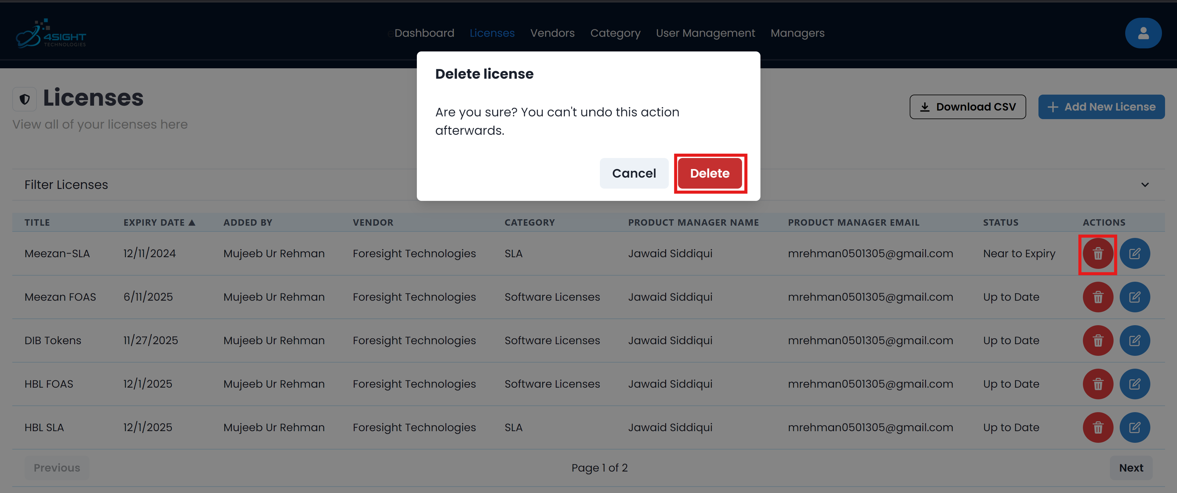

Figure 3.4: Example of how to delete a license

## Managing Categories

All management of categories can be done in the categories tab found in the top navigation bar.

Creating Categories

To add a category there are two easy steps. First, click on the “Add New Category” button. You will be prompted with a modal to input details of the category. Once you are done filling in the form, simply click “Save” and the category will be added and the record will be updated real time.

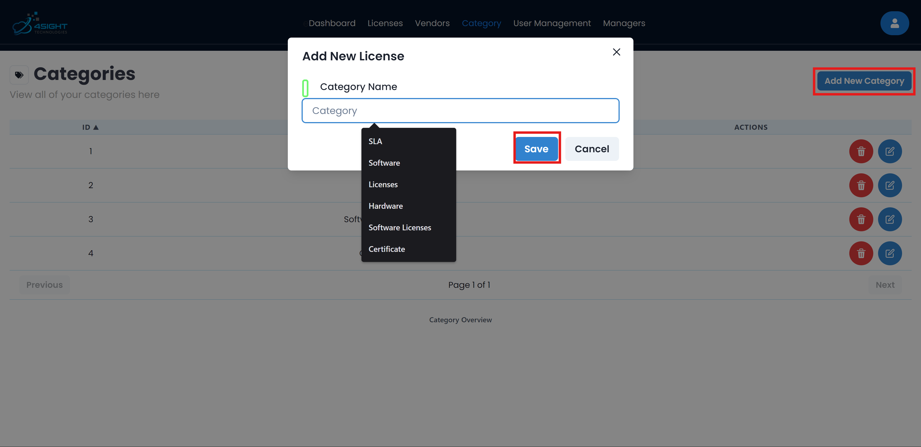

Figure 3.5: Example of how to add a category

Editing Categories

In order to edit a category simply click on the individual category “Edit” icon. Clicking it will trigger a drawer that would let you edit the category information. After editing the information, click on the “Submit” button and the effects will be seen instantly. By default, when the application is setup, you will see a “default” category in this tab.

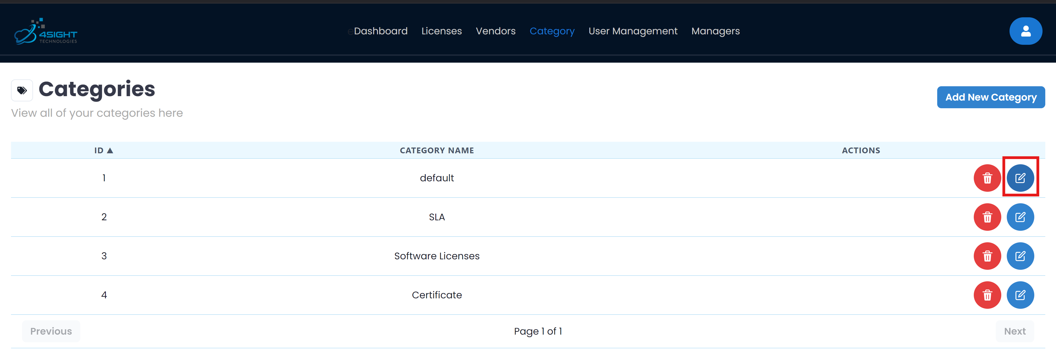

Figure 3.6: Step-1 to edit a category

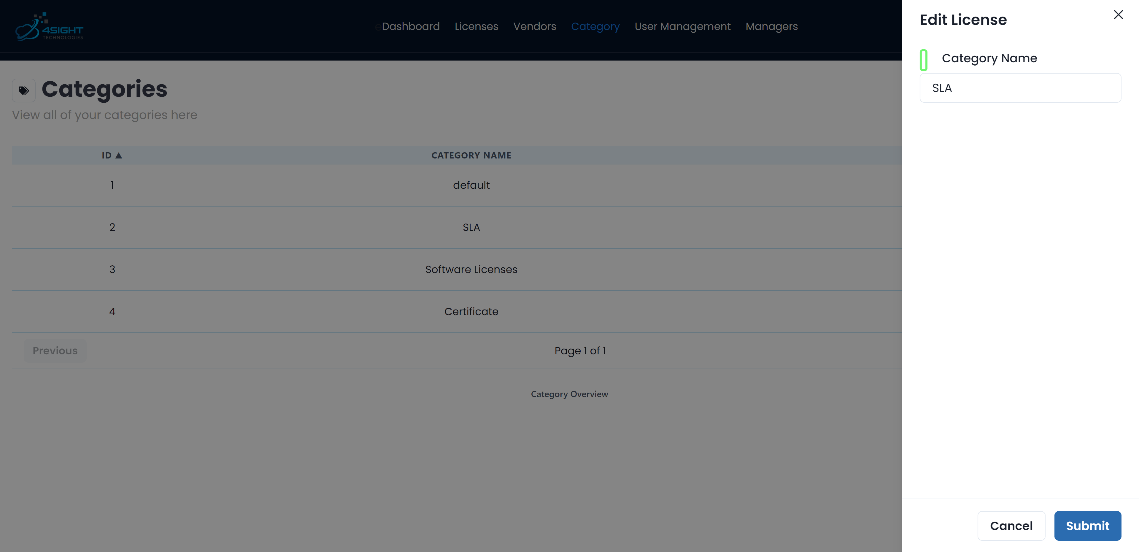

Figure 3.7: Step-2 to edit a category

Deleting Categories

Coming to deleting a category, it involves two simple steps. First, click on the delete icon appearing beside a category. Finally, click on “Delete” to successfully delete the category. It is worth noting that only Power Admins can delete a category.

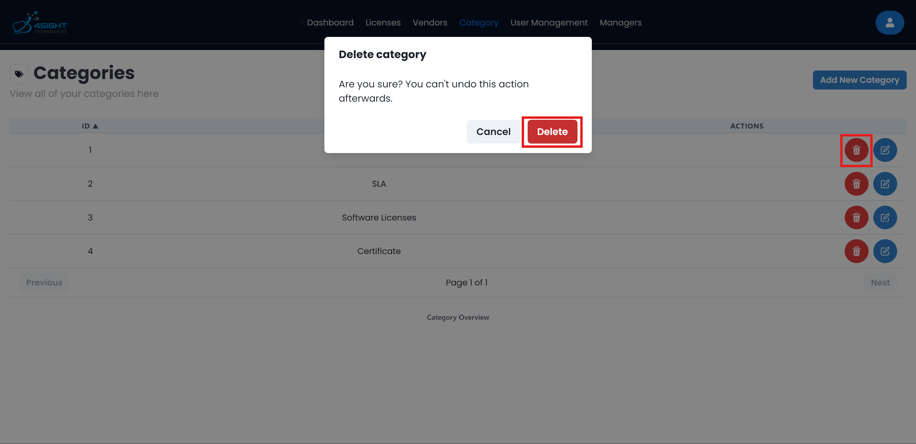

Figure 3.8: Example of how to delete a category

## Managing Vendors

All management of vendors can be done in the vendors tab found in the top navigation bar.

Adding Vendors

To add a vendor there are two easy steps. First, click on the “Add New Vendor” button. You will be prompted with a modal to input details of the vendor. Once you are done filling in the form, simply click “Save” and the vendor will be added and the record will be updated real time.

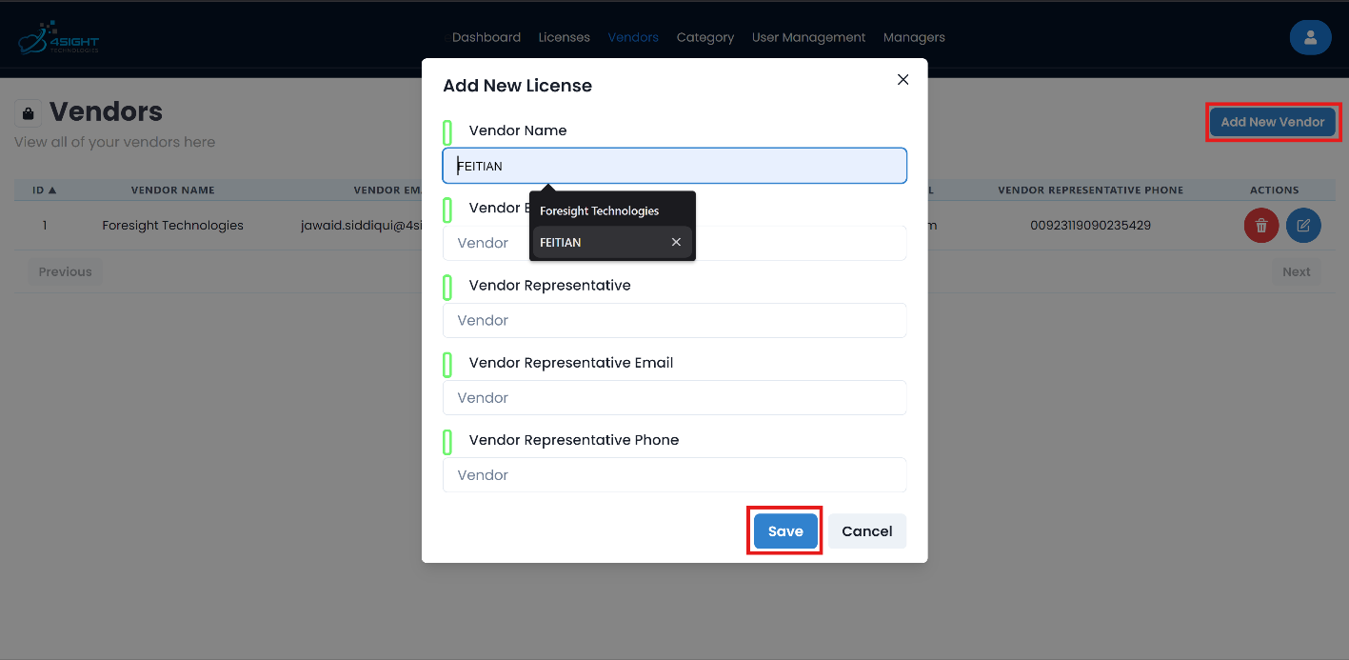

Figure 3.9: Example of how to add a vendor

Editing Vendors

In order to edit a vendor simply click on the individual vendor “Edit” icon. Clicking it will trigger a drawer that would let you edit the vendor information. After editing the information, click on the “Submit” button and the effects will be seen instantly.

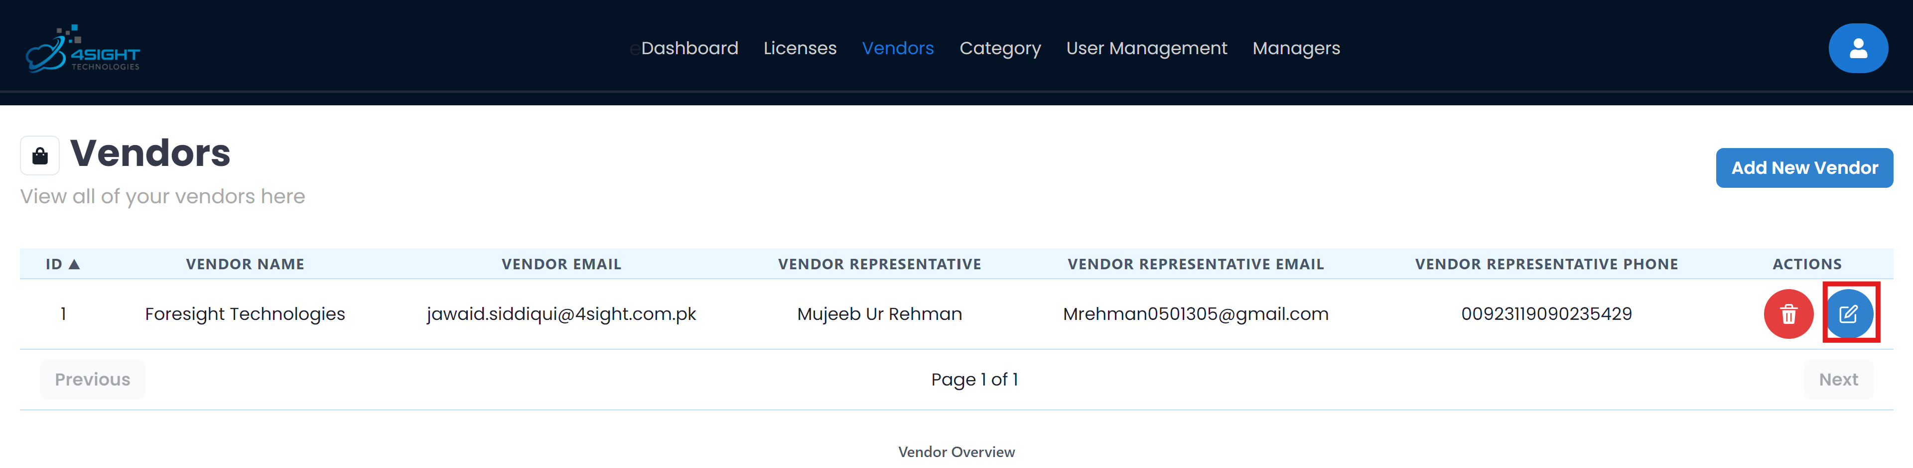

Figure 3.10: Step-1 to edit a vendor

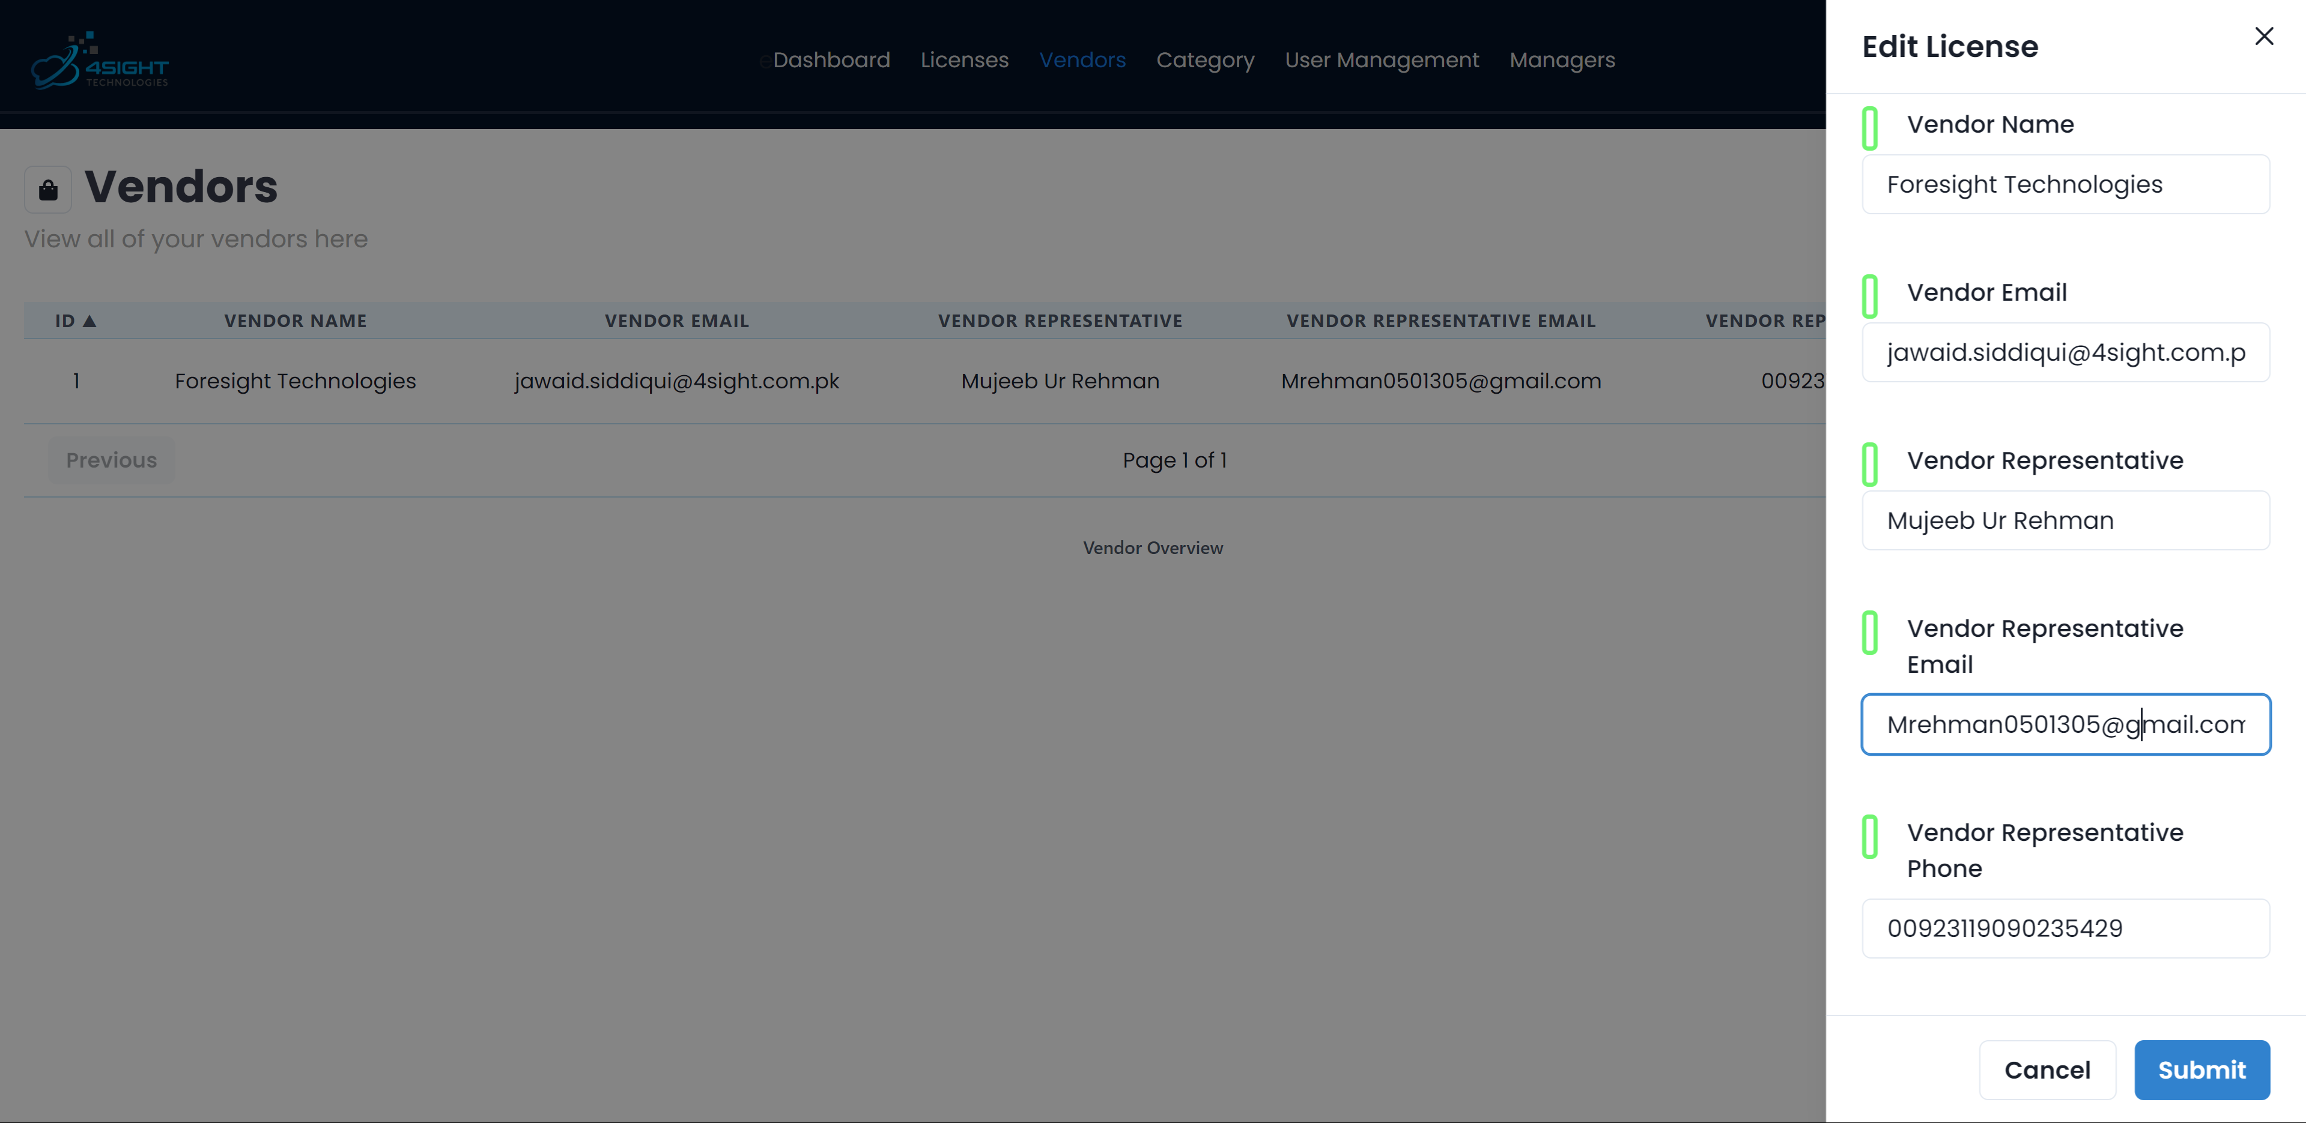

Figure 3.11: Step-2 to edit a vendor

Deleting Vendors

Coming to deleting a vendor, it involves two simple steps. First, click on the delete icon appearing beside a vendor. Finally, click on “Delete” to successfully delete the vendor. It is worth noting that only **Power Admins** can delete a vendor.

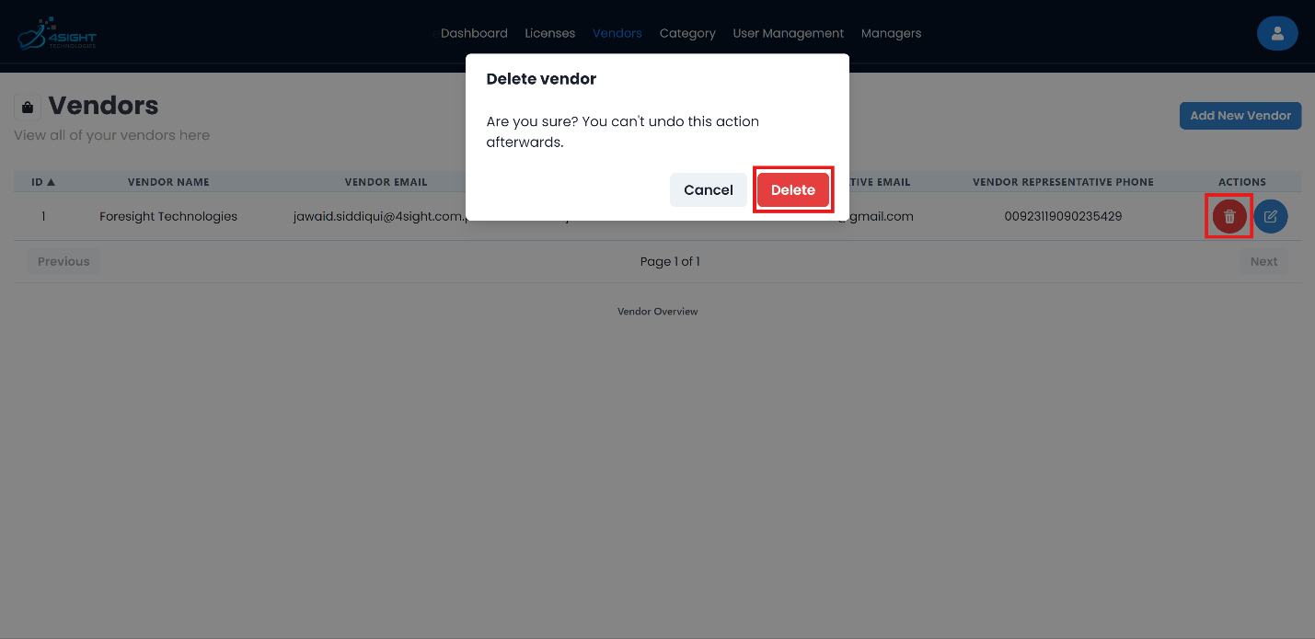

Figure 3.12: Example of how to delete a vendor

## User Management

The user management tab is restricted to only power admins, which means only the power/super admin has the capabilities to reset password, or disable a user, or even promote or demote a user from being admin.

Adding Users

To add a user, the user has to Sign-Up. Currently this is the only method to add a user, the admin can register for all the users and provide them with a common password which they can reset later.

Note: On client request, the application can be possibly modified based on the resources to add other options.

Editing Users

The power admin can reset your password, he can disable/enable your account, and finally, he can promote/demote you from being a admin. Hovering over any of the listed action, will display a tooltip, to ensure no confusion occurs.

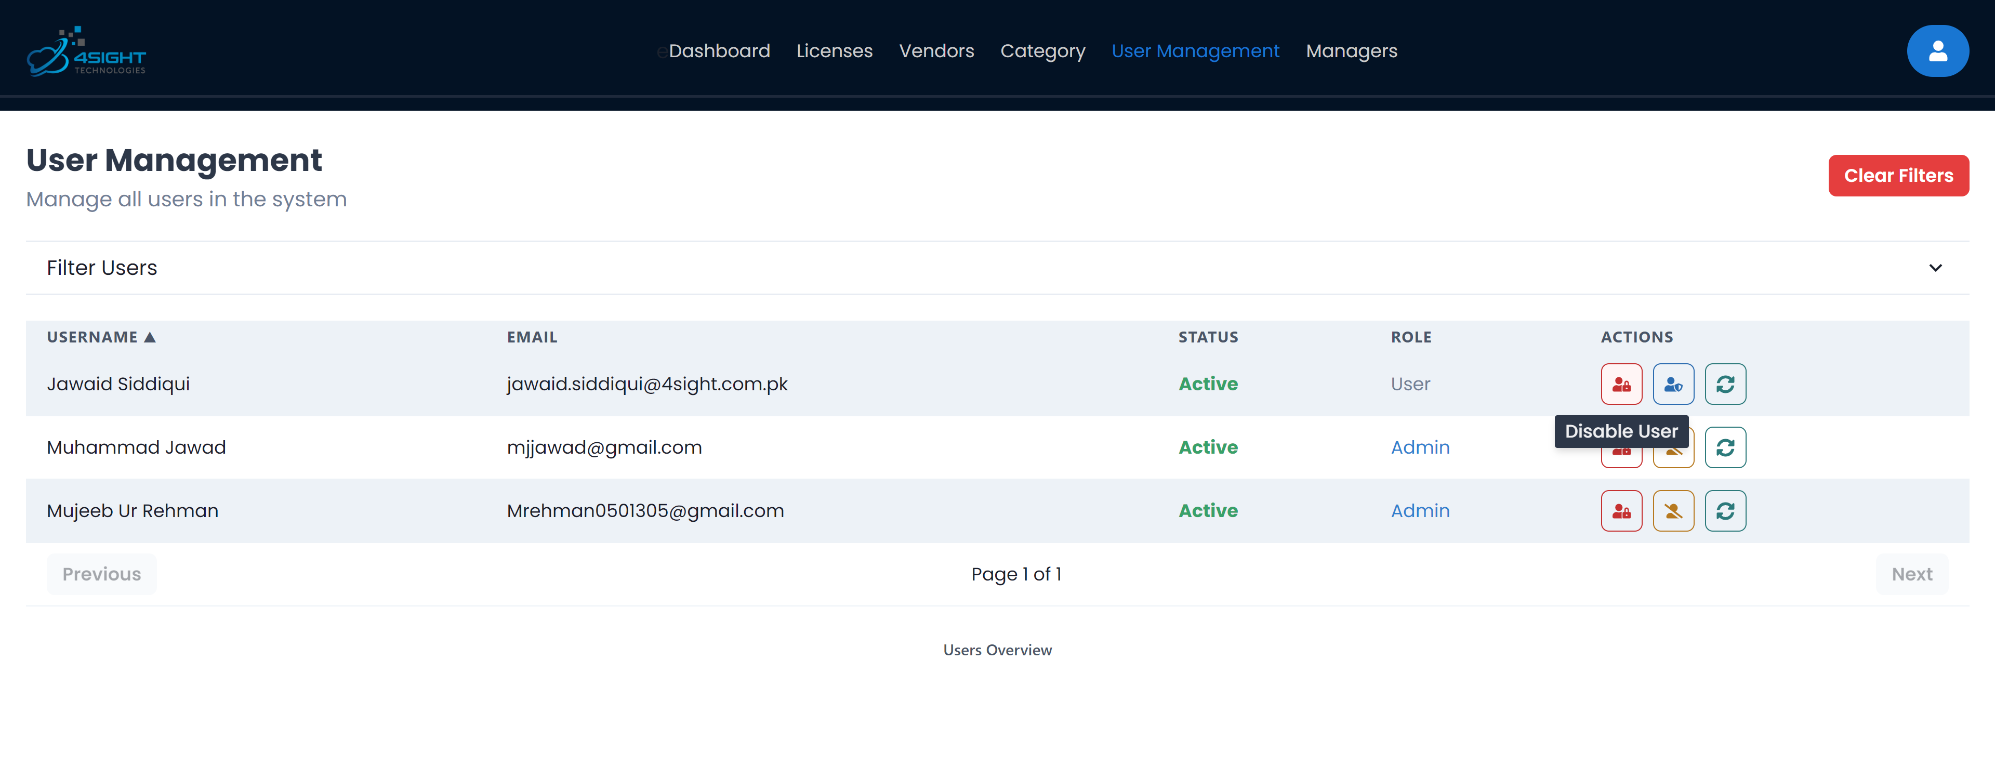

Figure 3.13: Showcasing actions a Super Admin can implement on a user

For a user, he can access the “My Profile” page by clicking on the person icon placed top right. It shows two options, the user can “Logout” or access “My Profile” page. This page displays your last login date/time along with your account active status.

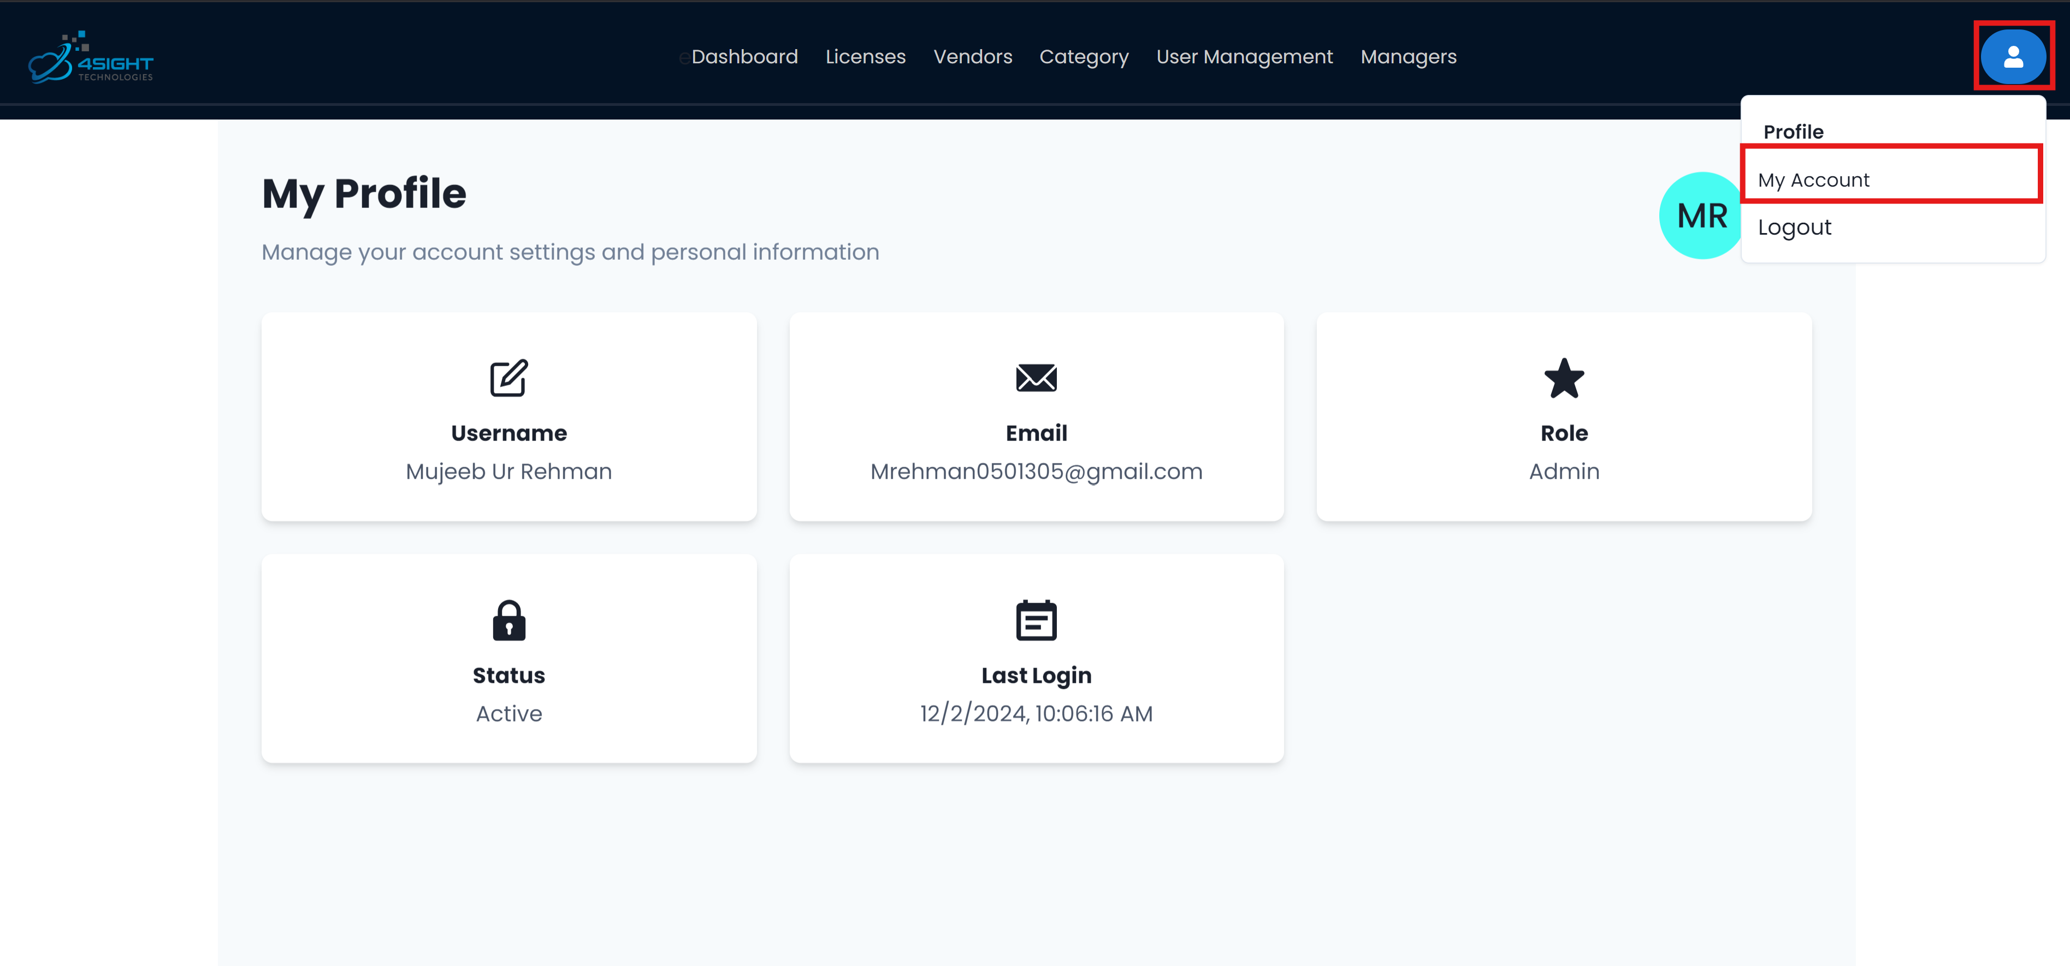

Figure 3.: How to access My Profile page

Using this page, you can update your password and username. First, click on the “edit” icon, this will open a drawer which allows you to edit your password and username. You do not need to fill in both fields, the credential you want to change just input that and it will update that specific credential.

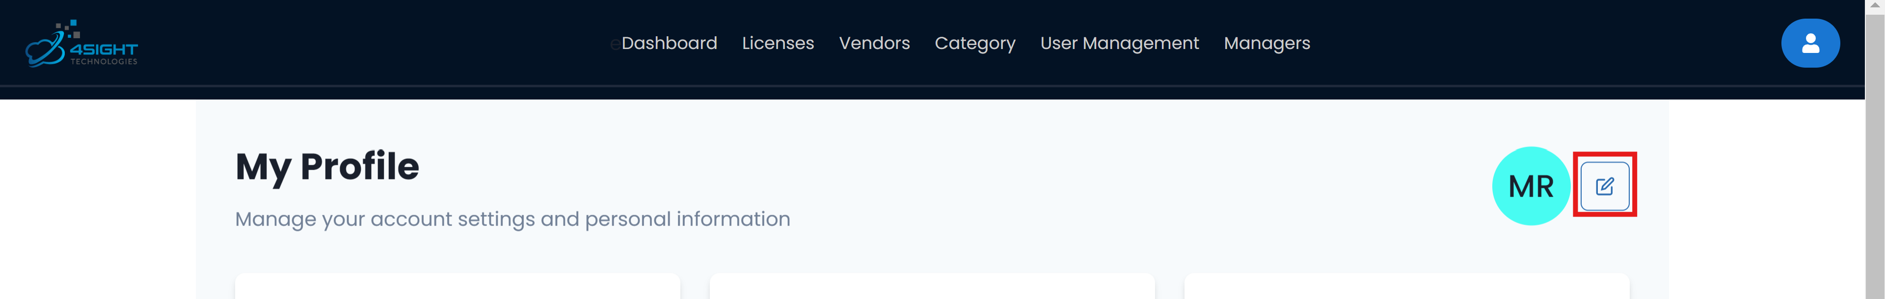

Figure 3.15: Step-1 to edit your information

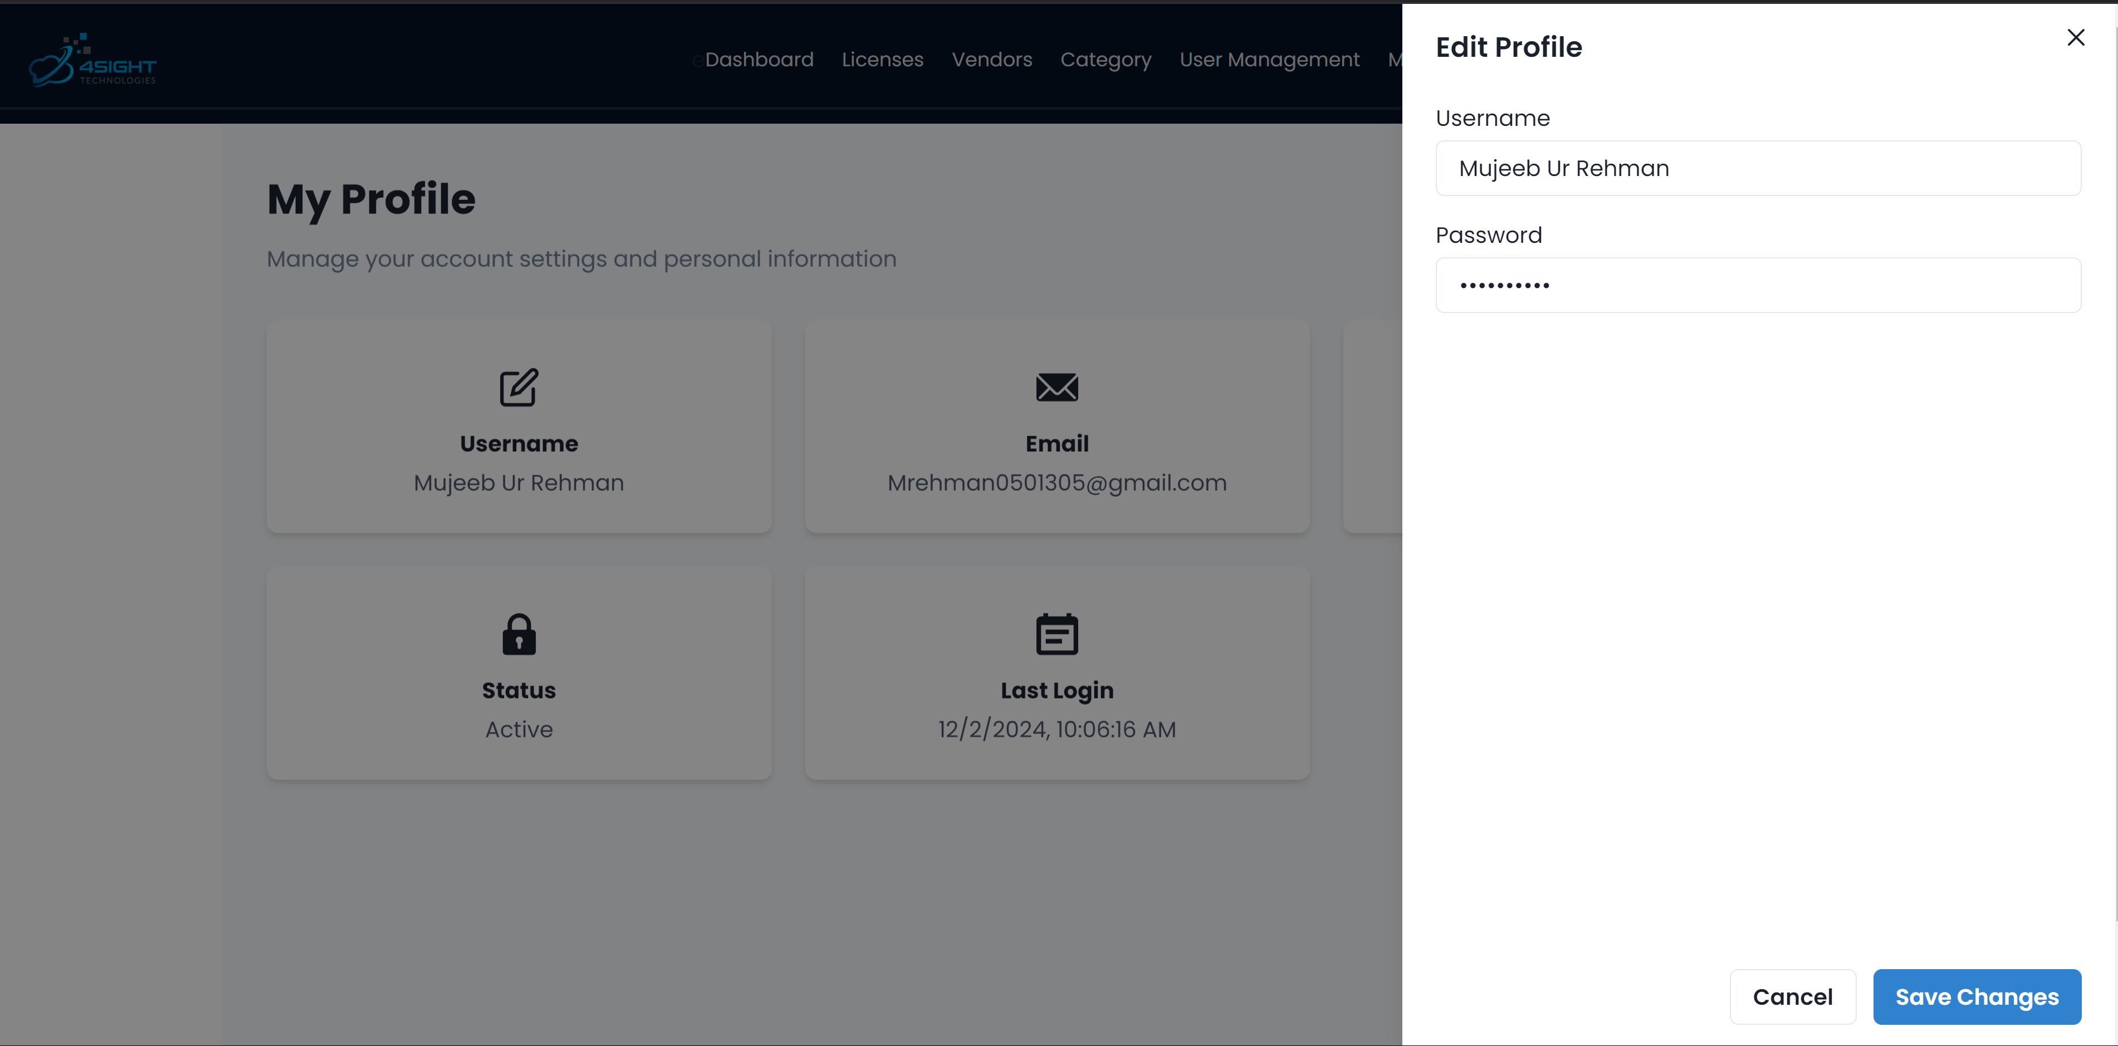

Figure 3.16: Step-2 to edit your information

## Managing Project Managers

All management of manager can be done in the managers tab found in the top navigation bar. The manager is important because he is the one who is notified through email of licenses approaching expiry. One is the user who added the license, and second is the project manager.

Adding a manager

To add a manager there are two easy steps. First, click on the “Add New Manager” button. You will be prompted with a modal to input details of the manager. Once you are done filling in the form, simply click “Save” and the manager will be added and the record will be updated real time.

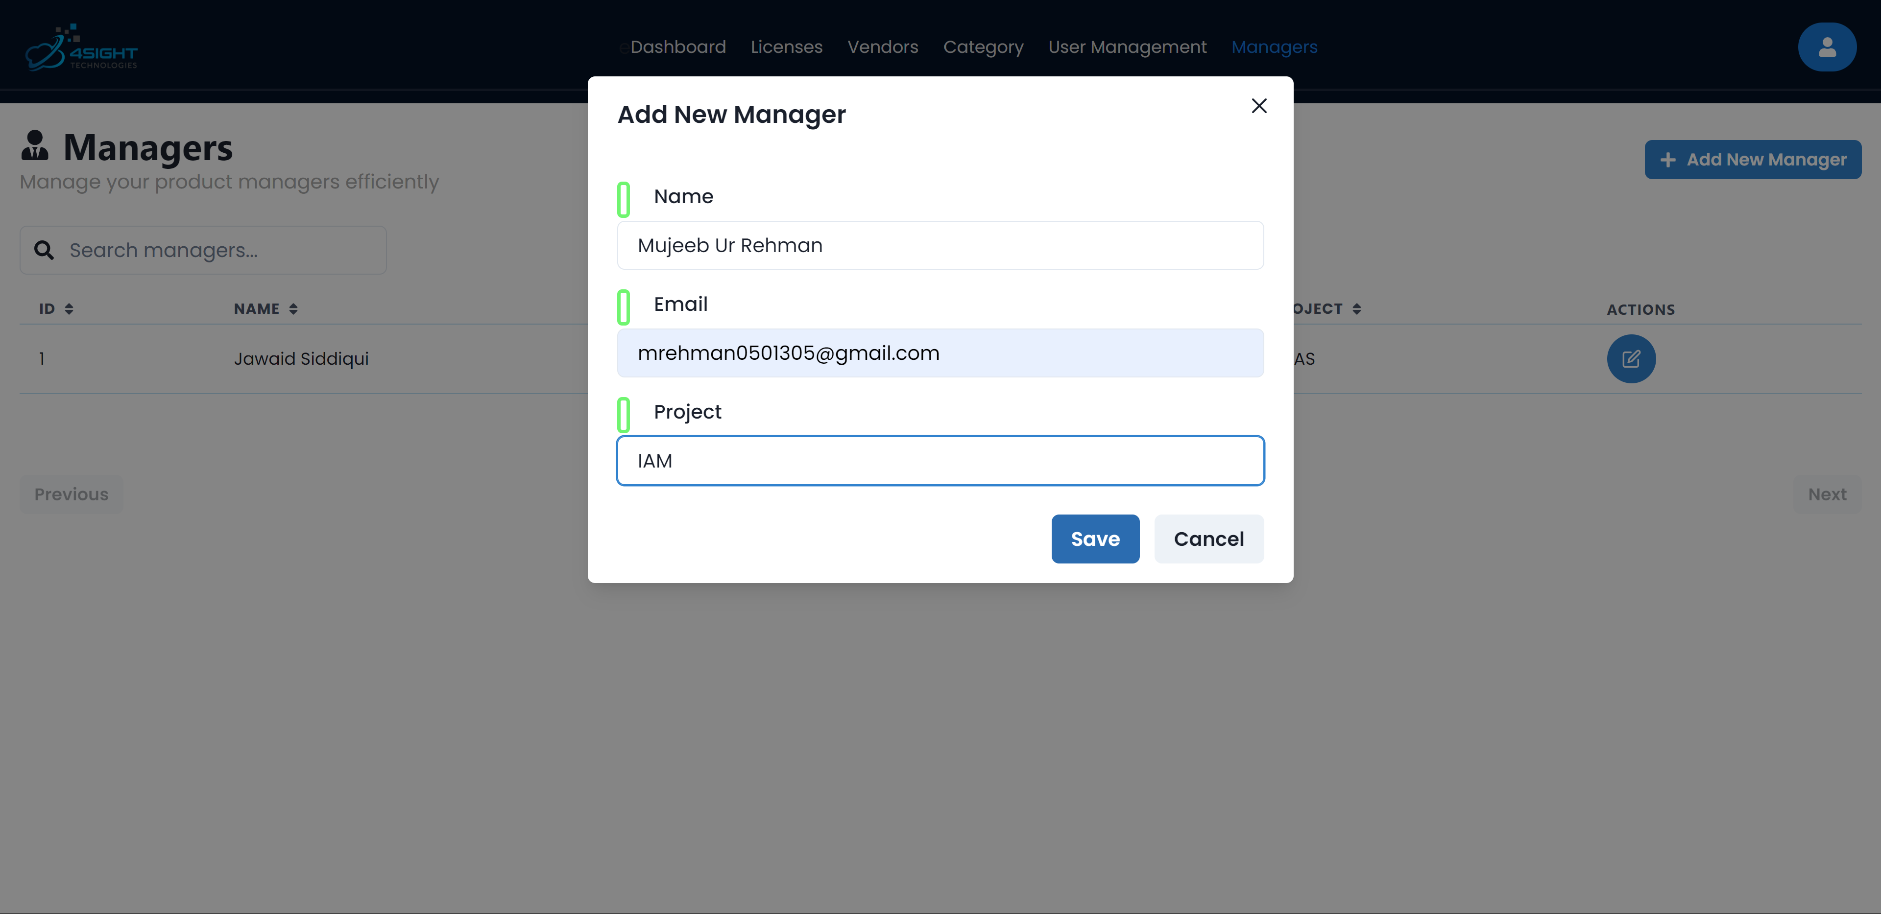

Figure 3.17: Example of how to add a manager

Editing manager info

In order to edit a manager simply click on the individual manager “Edit” icon. Clicking it will trigger a drawer that would let you edit the manager information. After editing the information, click on the “Submit” button and the effects will be seen instantly.

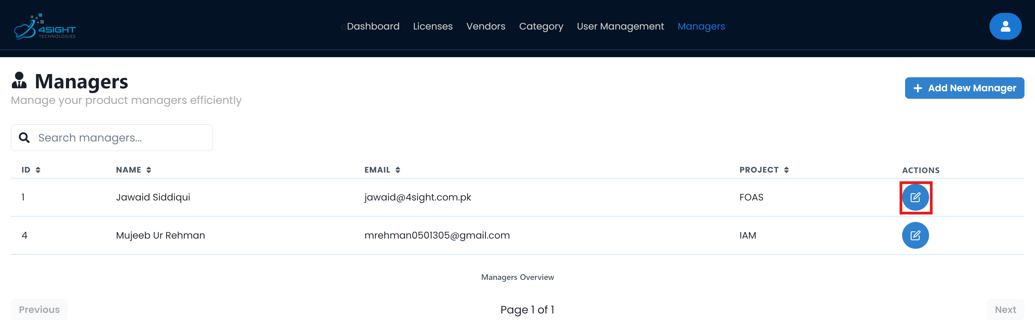

Figure 3.18: Step-1 to edit a manager

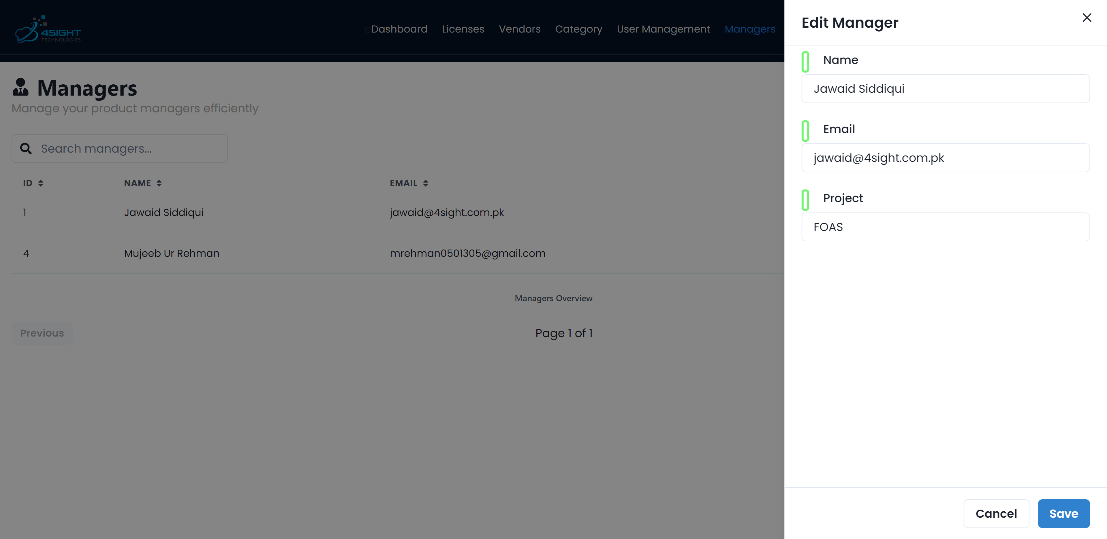

Figure 3.19: Step-2 to confirm edit of manager

# Advanced Features

## Calendar View

Viewing License Expiry Dates

On the main dashboard, an interactive calendar is placed to make it easy to view licenses approaching expiry. In the picture below you can see as an example, that SLA of Meezan is about to expire on 11th December. By default, it displays current month’s overview and we do not need to memorize any titles to filter on the licenses page. We can click on the license shown and it will redirect us to the license.

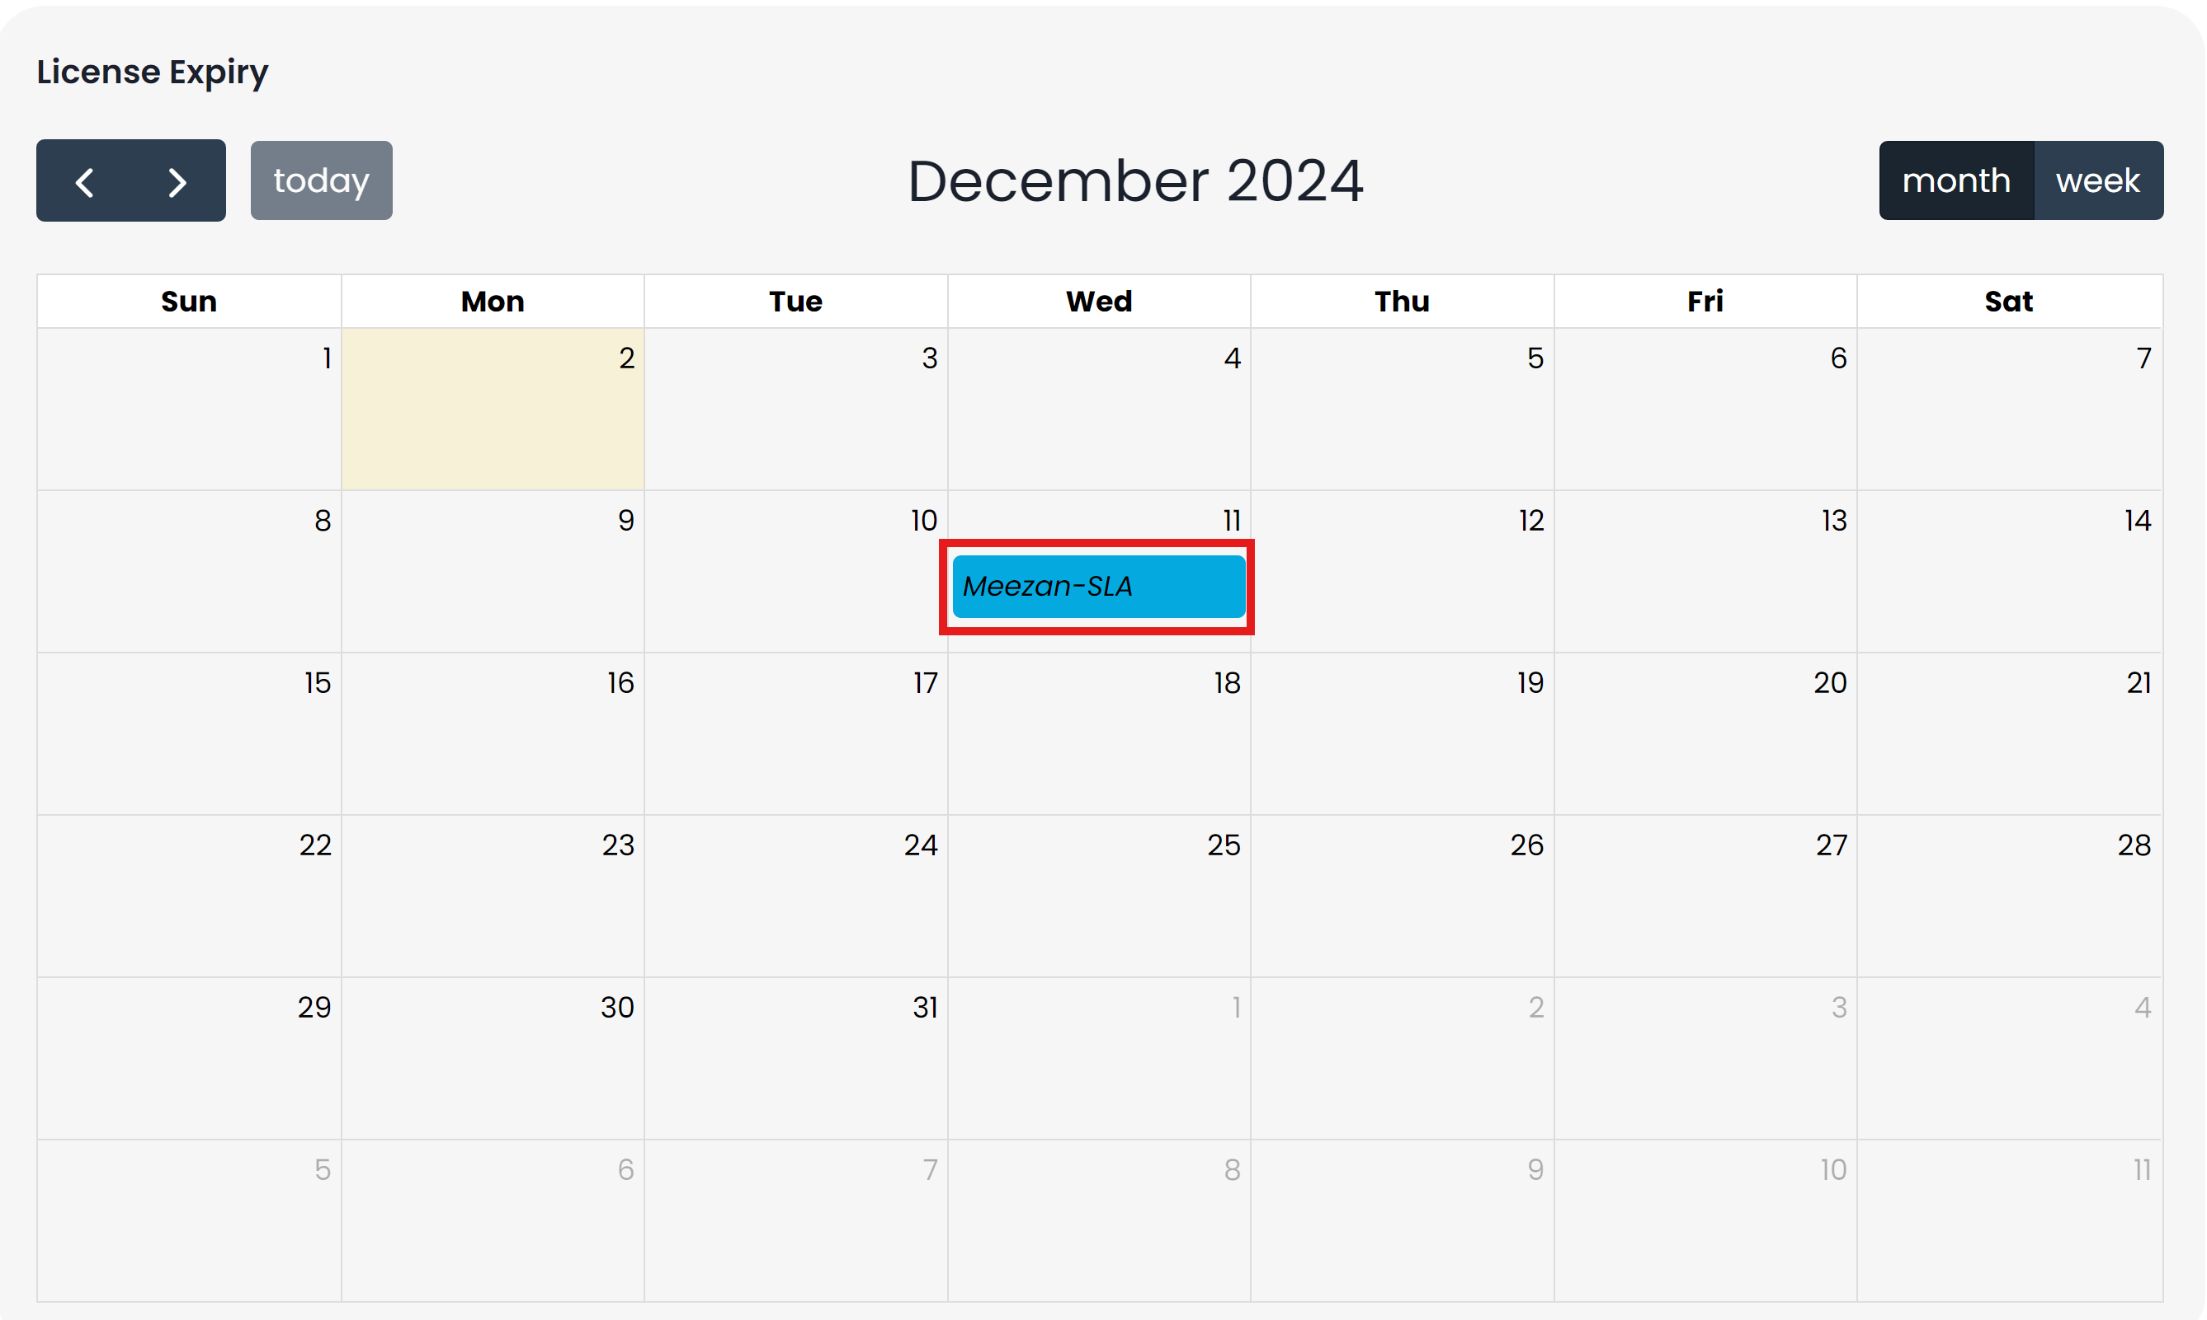

Figure 4.1: Calendar Overview

Navigating the Calendar

At the top, you have 4 options to navigate through the calendar.

1. By using the less than sign **“<”**, the calendar will navigate to the previous subsequent month.
2. By using the greater than sign “>”, the calendar will navigate to the upcoming subsequent month.
3. If you have navigated to another month, and want to return to the current month, by clicking on the “today” you will be brought back to the current month.
4. Lastly, you have the option to change the calendar view from monthly to weekly.

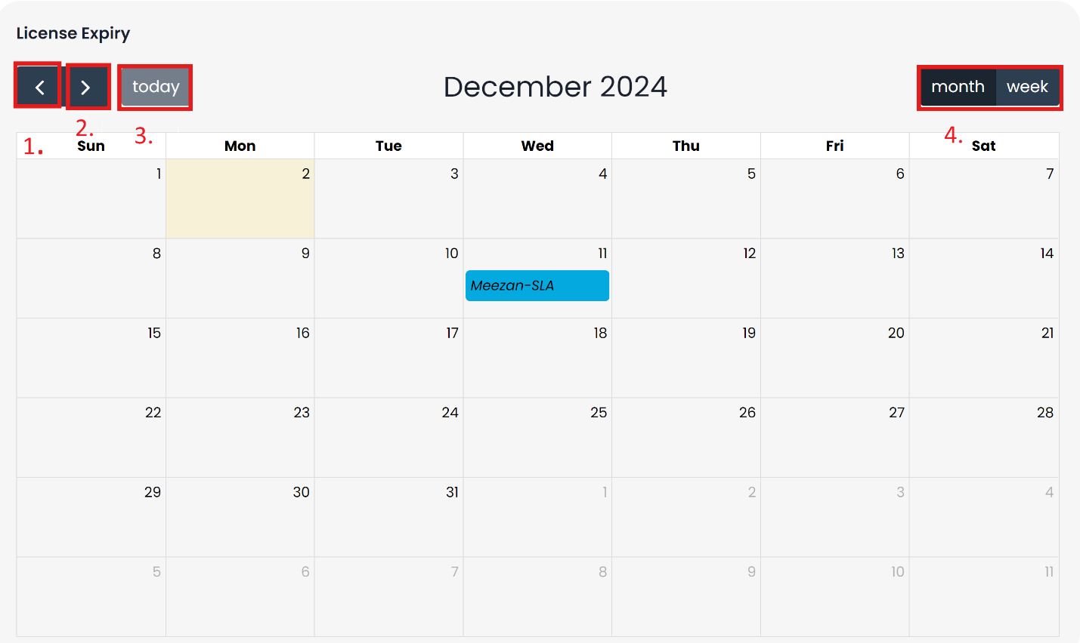

Figure 4.2: Highlighting calendar options

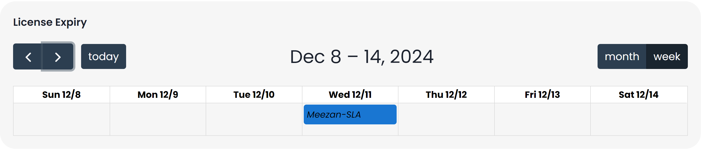

Figure 4.3: Example of weekly view of calendar

## CSV Export

Exporting License Data

The application gives an option to export all the licenses with a click of button to make the users job easy.

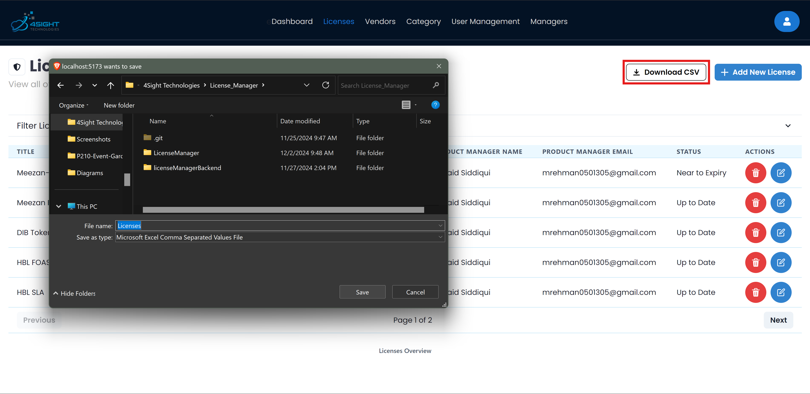

Figure 4.4: How to download licenses CSV

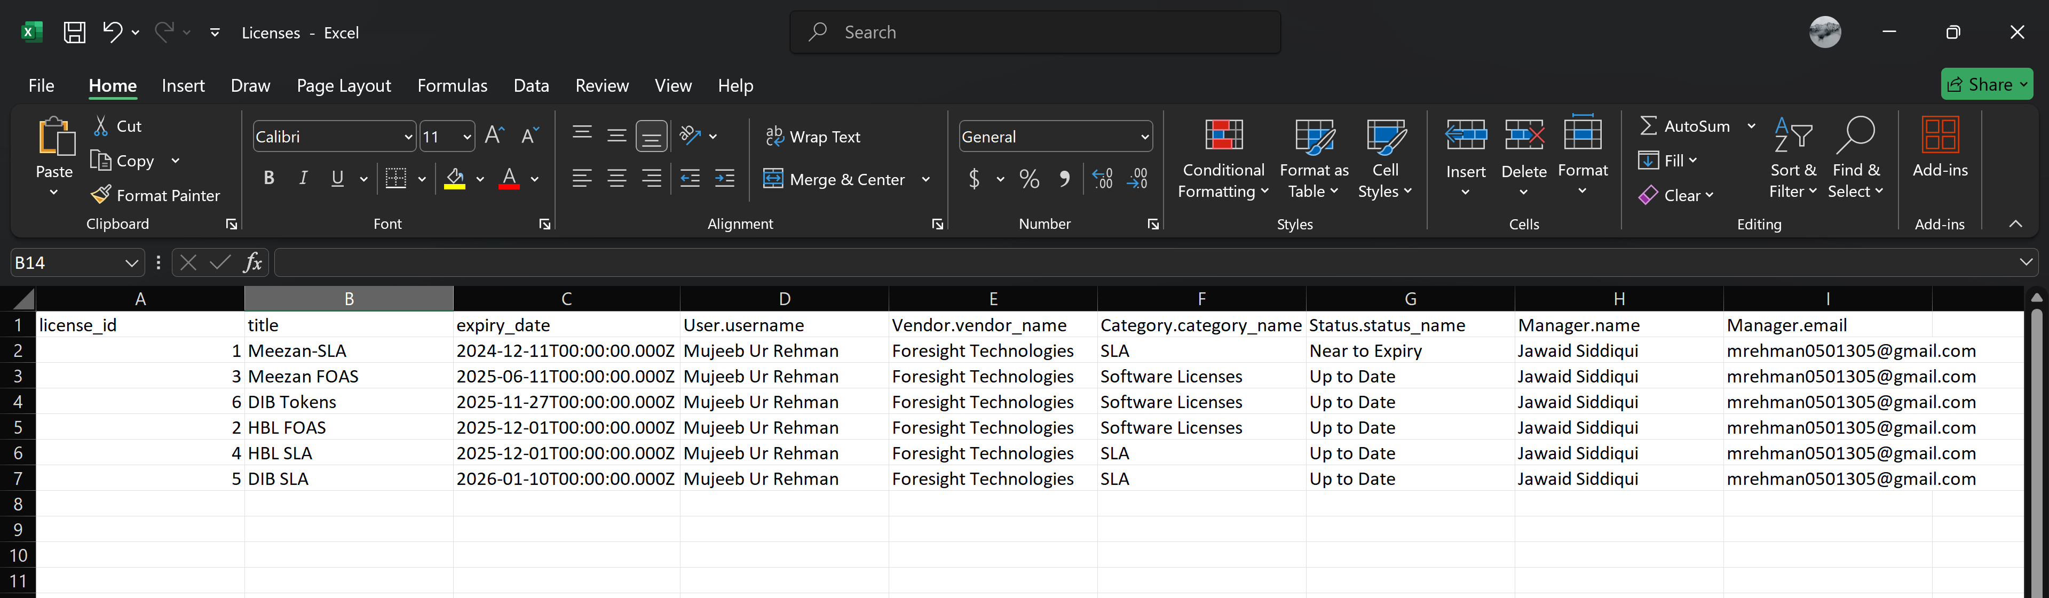

Figure 4.5: Example of downloaded CSV

# Customization

Here's a breakdown of possible customization options for the License Manager system, if there is something not listed, you can still inform us and we can work it out. An important thing to note is, that all changes will require “Letter of Intent” (LOI), any change will be further catered only in presence of “LOI” agreement.

## Minor Changes

These modifications can typically be implemented:

1. **Reporting Enhancements**
   * Custom report formats
   * Export capabilities (PDF, Excel, CSV)
   * Automated report scheduling
2. **Notification System**
   * Custom notification templates
   * Add notification recipients
   * Custom alert thresholds
3. **Logging and Monitoring**
   * Syslog integration
   * User activity logging
   * Log export functionality
4. **Security Enhancements**
   * 2FA implementation
   * Password policy customization

## Major Changes

These modifications typically require additional resources:

1. **Enterprise Integration**
   * Active Directory/LDAP integration
   * API integration with third-party systems
   * ERP system connectivity
2. **System Architecture**
   * Load balancing implementation
3. **Data Management**
   * Custom database integration
   * Automated data synchronization
   * Custom backup solutions

*Note: All customizations are subject to technical feasibility assessment and resource availability. Implementation timelines may vary based on complexity and scope.*

# Troubleshooting

## Common Issues

1. Something Went Wrong: When trying to Sign-In, or do any other action, A notification known as “toast” will appear on the screen. In case of this error, the first thing you need to check if your backend service is running. In 90% instances, the backend has stopped working and it gives a server error.

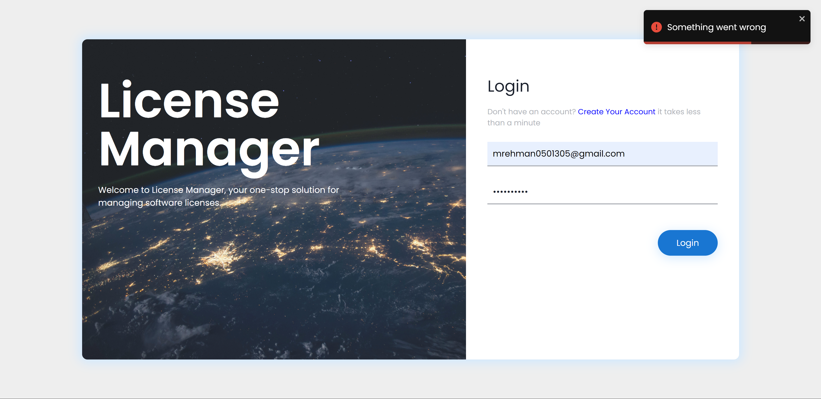

Figure 6.1: Example of a server error

1. Except this any warning or error is displayed with its relevant message. Some warnings include “Only Power Admins can delete” or “Only Admins can edit”.

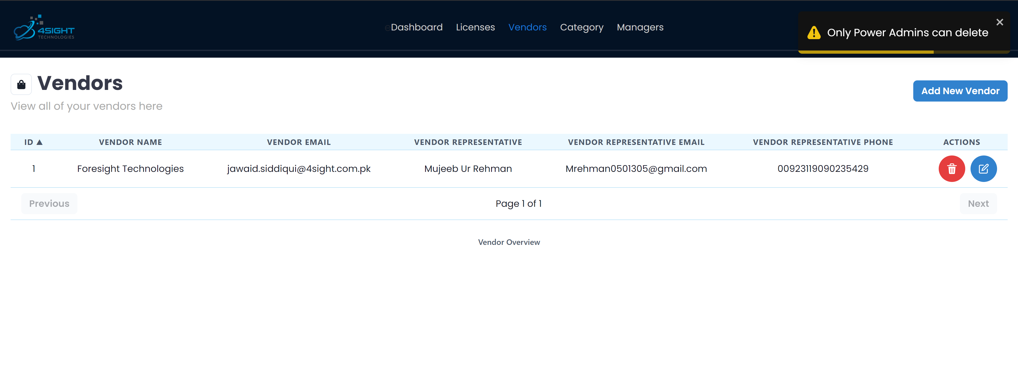

Figure 6.2: Example of privileges warning

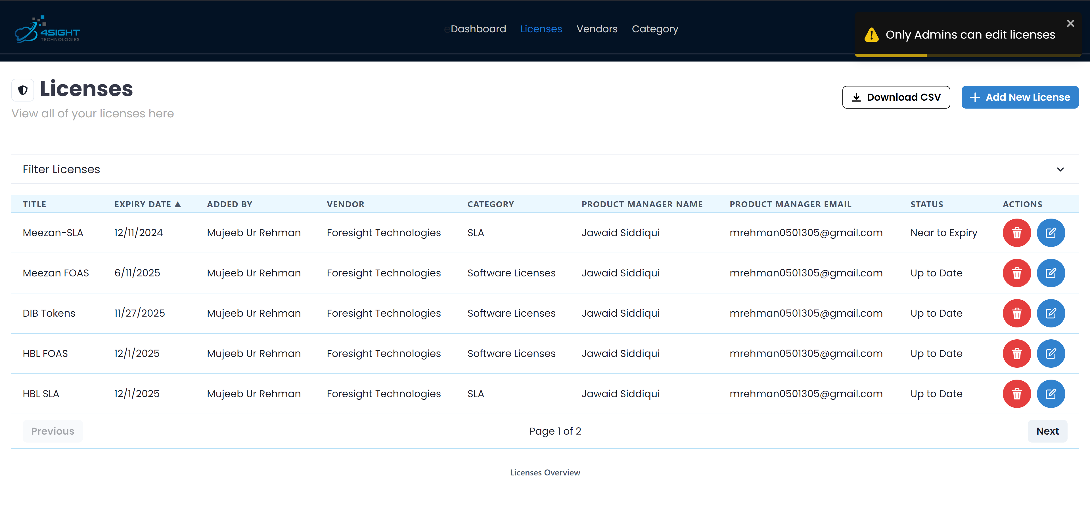

Figure 6.3: 2nd Example of privileges warning

1. A very important error that can only be solved by the application provider is regarding the applications license. If you see any error regarding the license, it means either the license has expired, or has been altered or it is missing from the location.

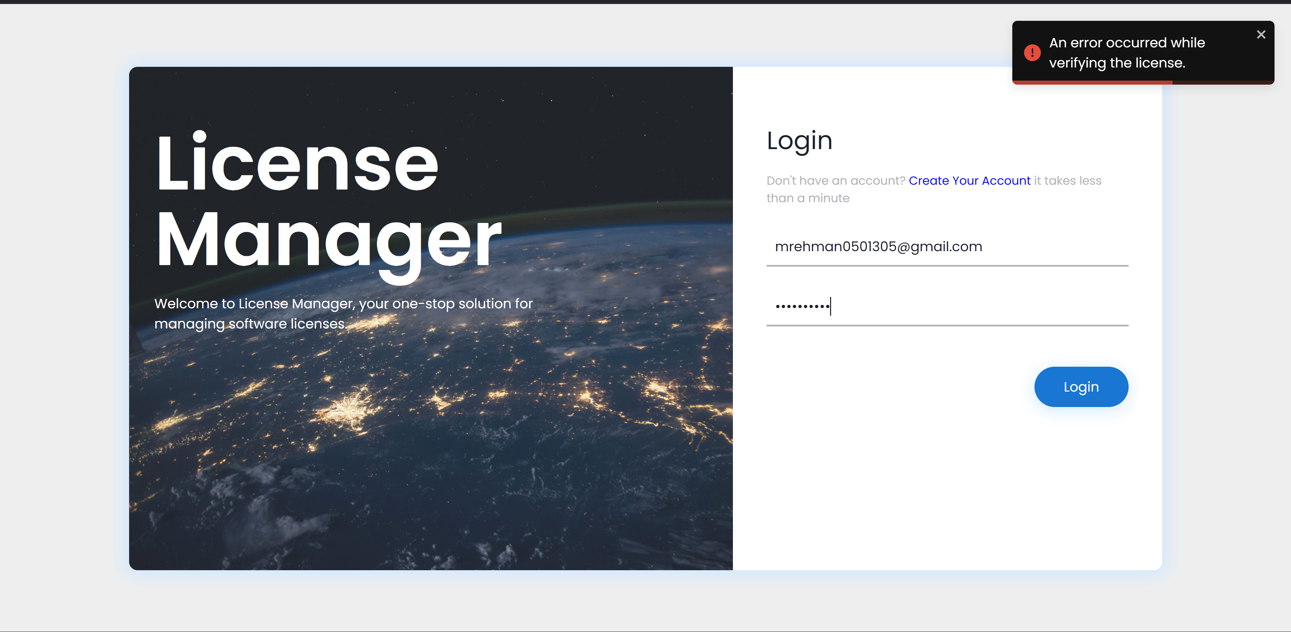

Figure 6.4: Example of error in case of license verification fail

## Frequently Asked Questions (FAQ)

**Q1: How does the license verification system work?**

The system uses a combination of hardware-based identification and cryptographic verification. It generates a unique hardware ID based on the CPU model and disk drive serial number, which is then used to validate the license. This ensures the license can only be used on the authorized machine.

**Q2: What happens when a license is about to expire?**

The system employs multiple notification mechanisms:

* Email notifications are automatically sent through a “cron” job that runs daily at 9 AM
* Visual indicators in the dashboard calendar show upcoming expiration dates
* A dedicated notifications tab displays licenses expiring within the next 7 days
* License status automatically updates to "warning" when within one month of expiration

**Q3: What are the different user roles in the system?**

The system supports three levels of user access:

* **Super Admin**: Has complete system access, including password reset capabilities
* **Admin**: Can manage licenses, categories, vendors, and managers. However, cannot delete any of the records.
* **Regular User**: Can view and track assigned licenses

**Q4: How are license activities tracked?**

The system maintains detailed logs of all license-related activities including:

* Creation and modification of licenses
* User actions

**Q5: What security measures are implemented?**

The system implements multiple security layers:

* JWT (JSON Web Token) based authentication
* Encrypted password storage using bcrypt
* Hardware-based license validation
* Role-based access control
* Secure session management
* The database and email passwords in the .env file are encrypted once the application starts, to ensure no one can see the password.

**Q6: How can I manage multiple vendors and categories?**

The system provides dedicated interfaces to:

* Create and edit vendor profiles
* Organize licenses by categories
* Assign managers to specific licenses
* Filter and search across all parameters

**Q7: How does the automated notification system work?**

The notification system:

* Runs daily checks for expiring licenses
* Sends email notifications to relevant stakeholders
* Updates the dashboard notification center

**Q8: Can the system handle multiple organizations or departments?**

Yes, the system supports:

* Multiple manager assignments
* Segregated license management
* Role-based access control for different organizational units

**Q9: Is it possible to use a single license file on multiple machines.**

No, a single license file will only work on a single machine, as when generating it, the machines hardware information is also fetched and encrypted into the license. Due to this, a license file will work only on a single machine.

For additional support or technical assistance, please contact the system administrator or refer to the technical documentation.

Support

1. Jawaid Iqbal Siddiqui – Manager Software Engineer at Foresight Technologies

[jawaid.siddiqui@4sight.com.pk](mailto:jawaid.siddiqui@4sight.com.pk)

1. Muhammad Mujeeb Ur Rehman – Software Engineer at Foresight Technologies

[mujeeb.rehman@4sight.com.pk](mailto:mujeeb.rehman@4sight.com.pk)

# Appendices

## Glossary

* **Hardware ID**: Unique identifier generated from system hardware components
* **JWT**: JSON Web Token used for secure authentication
* **Manager**: User responsible for overseeing specific licenses
* **Status**: License state (Up to Date, Near to Expiry, Expired)
* **Vendor**: Software provider or manufacturer
* **Category**: License classification group
* **Cron Job**: Scheduled task that runs automatically
* **Super Admin**: Highest level of system access
* **License Key**: Encrypted validation code

## References

* Node.js Documentation: For backend server implementation
* React Documentation: For frontend development
* MySQL Documentation: For database management
* Sequelize Documentation: For ORM implementation
* Express.js Documentation: For API routing
* Redux Documentation: For state management
* Chakra UI Documentation: For UI components
* PM2 Documentation: For process management
* Node-cron Documentation: For scheduled tasks

## Contact Information

* Technical Support/License Inquiry:

[jawaid.siddiqui@4sight.com.pk, mujeeb.rehman@4sight.com.pk]

* System Administrator: [Jawaid Iqbal Siddiqui, Muhammad Mujeeb Ur Rehman]
* Emergency Support: [emergency contact]